Sleep Inertia Analysis

DESCRIPTION OF DOCUMENT

Here you’ll find all analyses conducted on the sleep inertia data.

I plan to update this as time goes by.

Use the document outline on the left to sort through the long list figures

CURRENT OUTLINE

Current Title and Abstract

Data analysis using EEG data during PVT Task

Data analysis using EEG data during KDT Task

Data analysis using EEG data during MATH Task

Data analysis using EEG data during GONOGO Task

# Current Title and Abstract

CURRENT TITLE

Temporal evolution of brain connectivity upon awakening from slow wave sleep varies by cognitive task

ABSTRACT

Sleep inertia refers to the state of transition between sleep and wake characterized by impaired alertness, confusion, and reduced cognitive and behavioral performance. While the neurobehavioral symptoms of sleep inertia are well-described, less is known about the temporal evolution of brain connectivity that characterize sleep inertia and the cognitive specificity of these effects. Previously, using electroencephalography (EEG), we have shown during a psychomotor vigilance task (PVT), that upon awakening, global power within lower frequency bands returns to baseline levels before higher frequencies. This observation was also accompanied by changes in network metrics in the lower frequency bands, specifically, change in average *clustering coefficient*, which measures how likely two neighbors of a node are connected to one another, and average *path length*, which measures the average shortest path between every node pair. Here we extend these findings to a restful awake segment (Karolinska Drowsiness Test; KDT), a Go/No-Go task (GNG), and an arithmetic task (MATH), to understand the specificity and task interactions of these effects. After mild restriction the night before (5h time-in-bed), participants were brought to the laboratory and participated in a baseline assessment of task performance and neural metrics before sleep. Participants were then allowed to sleep and were woken up in slow wave sleep (SWS) by an experimenter who gave them an intervention (blue-enriched light, dim red light) and then led them through the four tasks (PVT, MATH, GNG, KDT) consecutively four times (T1-4). Similar to our previous findings, for the KDT, GNG, and MATH tasks, high frequency differences in global power between baseline and other test bouts were largely retained. Interestingly, clustering and path length differences between baseline and the test bouts (T1-4) were largely absent in the low frequencies; however, within the beta band whilst participants were engaged in the MATH task, we observed a significant change from baseline in T2-4 for both clustering and path length. This effect was largely attenuated with an intervention of blue-enriched light; however, the blue-enriched light intervention also significantly increased clustering coefficient in the delta band above baseline levels. Considering the stability of the power effects across tasks and the specificity of the network metrics effects to tasks, these two approaches suggest that two different neural schemes underlying sleep inertia, one that gradually recovers and impacts all that we do (i.e., power) and one that is sensitive to task and intervention, reconfiguring the brain as new task demands emerge.

# 

# — — —

# PVT Data Analysis

This analysis uses all of the eeg data collected during the PVT task.

For this analysis, data from 11 subjects were used.

Same as those in the original analysis (out of the 12 subjects, only subject 8 was removed)

Reading the figures.

* On the bottom row of each figure, there is a matrix whose elements represent the t-statistic from comparing pairs of conditions. The names of the conditions can be found on the row and column. Stars represent a significant difference and, if there is a difference, the t-value is shown .

## Betweenness Centrality during PVT

### Figure 1a: Time course of **Betweenness centrality** after awakening WITHOUT blue light exposure

Notes

* Betweenness centrality across all frequencies remains unchanged after awakening in the control condition

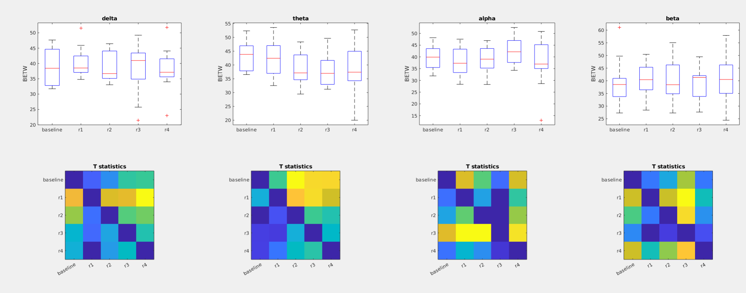

### Figure 1b: Time course **Betweenness centrality** after awakening **WITH** **Blue Light Exposure**

*Exposure to blue-light immediately after awakening reduces theta betweenness which reverts back to baseline within 30 minutes*

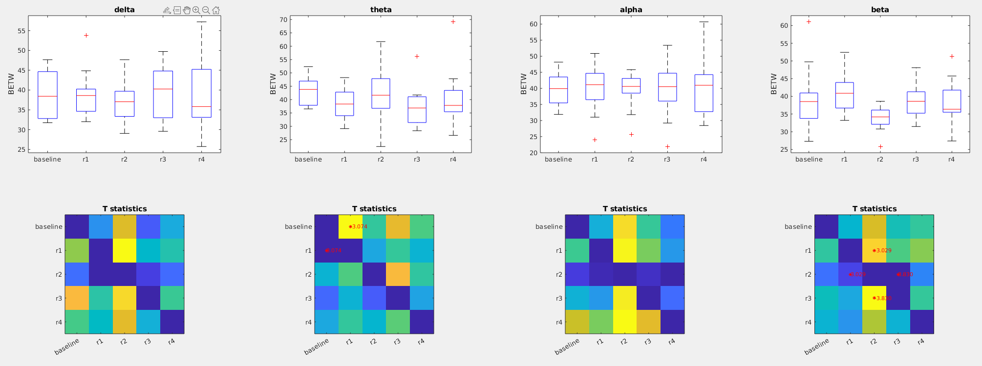

### Figure 1c: **Betweeness Centrality** during preseleep (**baseline**) Vs awakening WITHOUT light exposure (**control_R1**) vs Awakening WITH light exposure (**light_R1**)

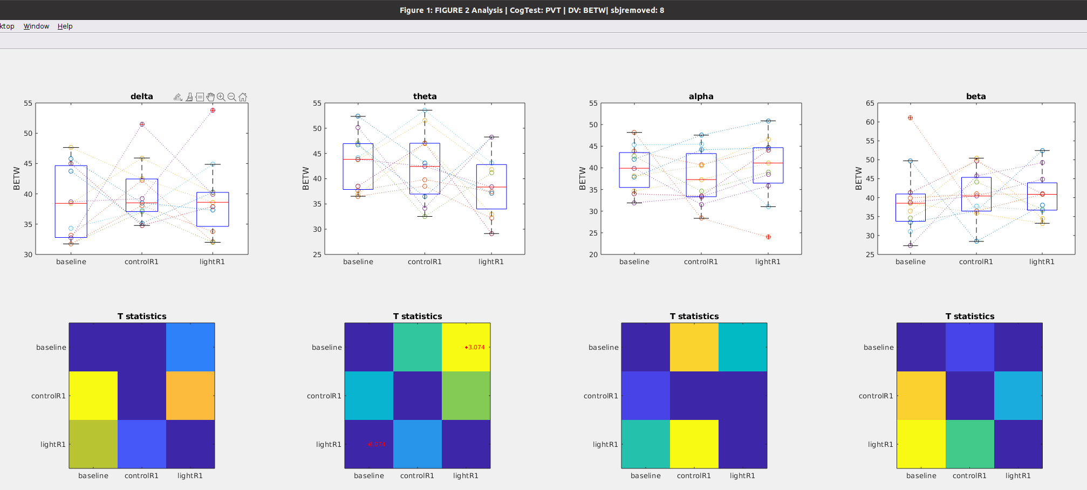

## WPLI during PVT

### Figure 2A: Time course of **WPLI** after awakening WITHOUT blue light exposure

*Under control conditions, Theta WPLI decreases about 30 minutes after awakening and does not recover within 45 minutes (the 4th test)*

*Under control conditions, there are no changes in delta, alpha and beta WPLI after awakening*

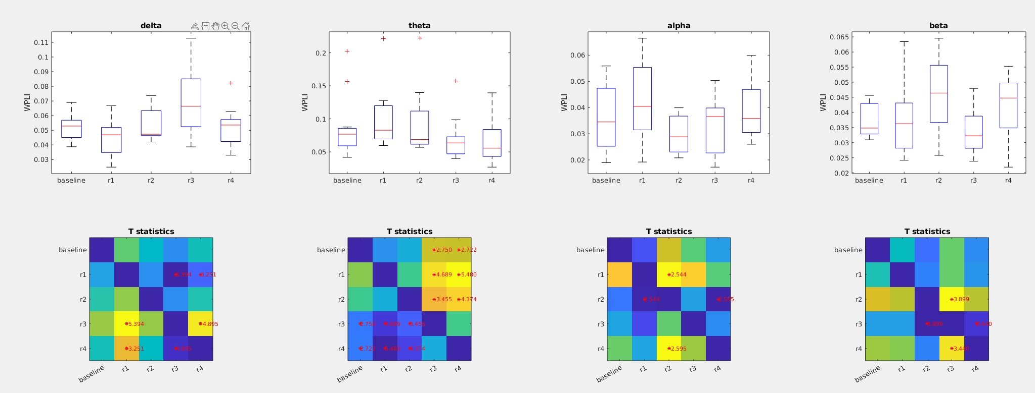

### Figure 2B: Time course of **WPLI** after awakening WITH **Blue-Light Exposure** (eeg data gathered during performance on PVT task)

*Blue light exposure increases WPLI in the delta band and does not recover back to baseline within 45 minutes (the 4th test) (see the first column)*

*Blue light exposure after awakening prevents changes in Theta WPLI (second column)*

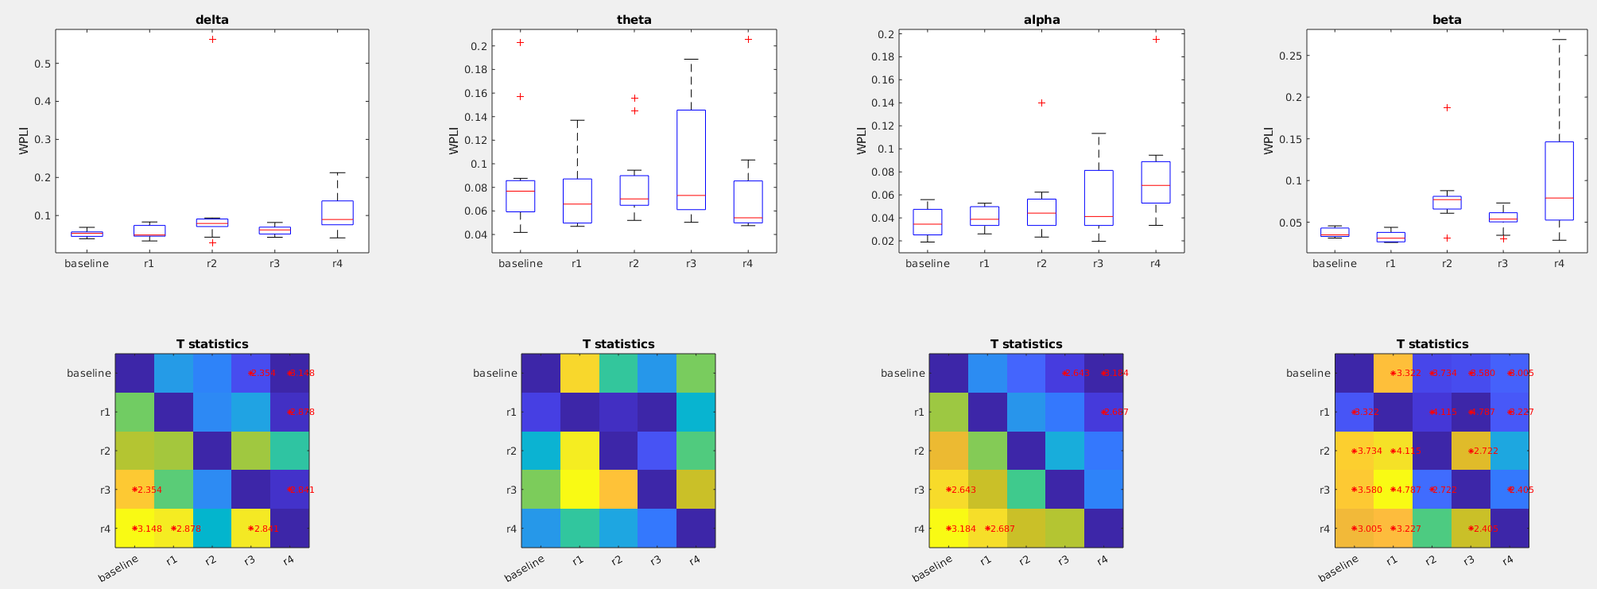

### Figure 2c: **WPLI** during preseleep (**baseline**) Vs awakening WITHOUT light exposure (**control_R1**) vs Awakening WITH light exposure (**light_R1**)

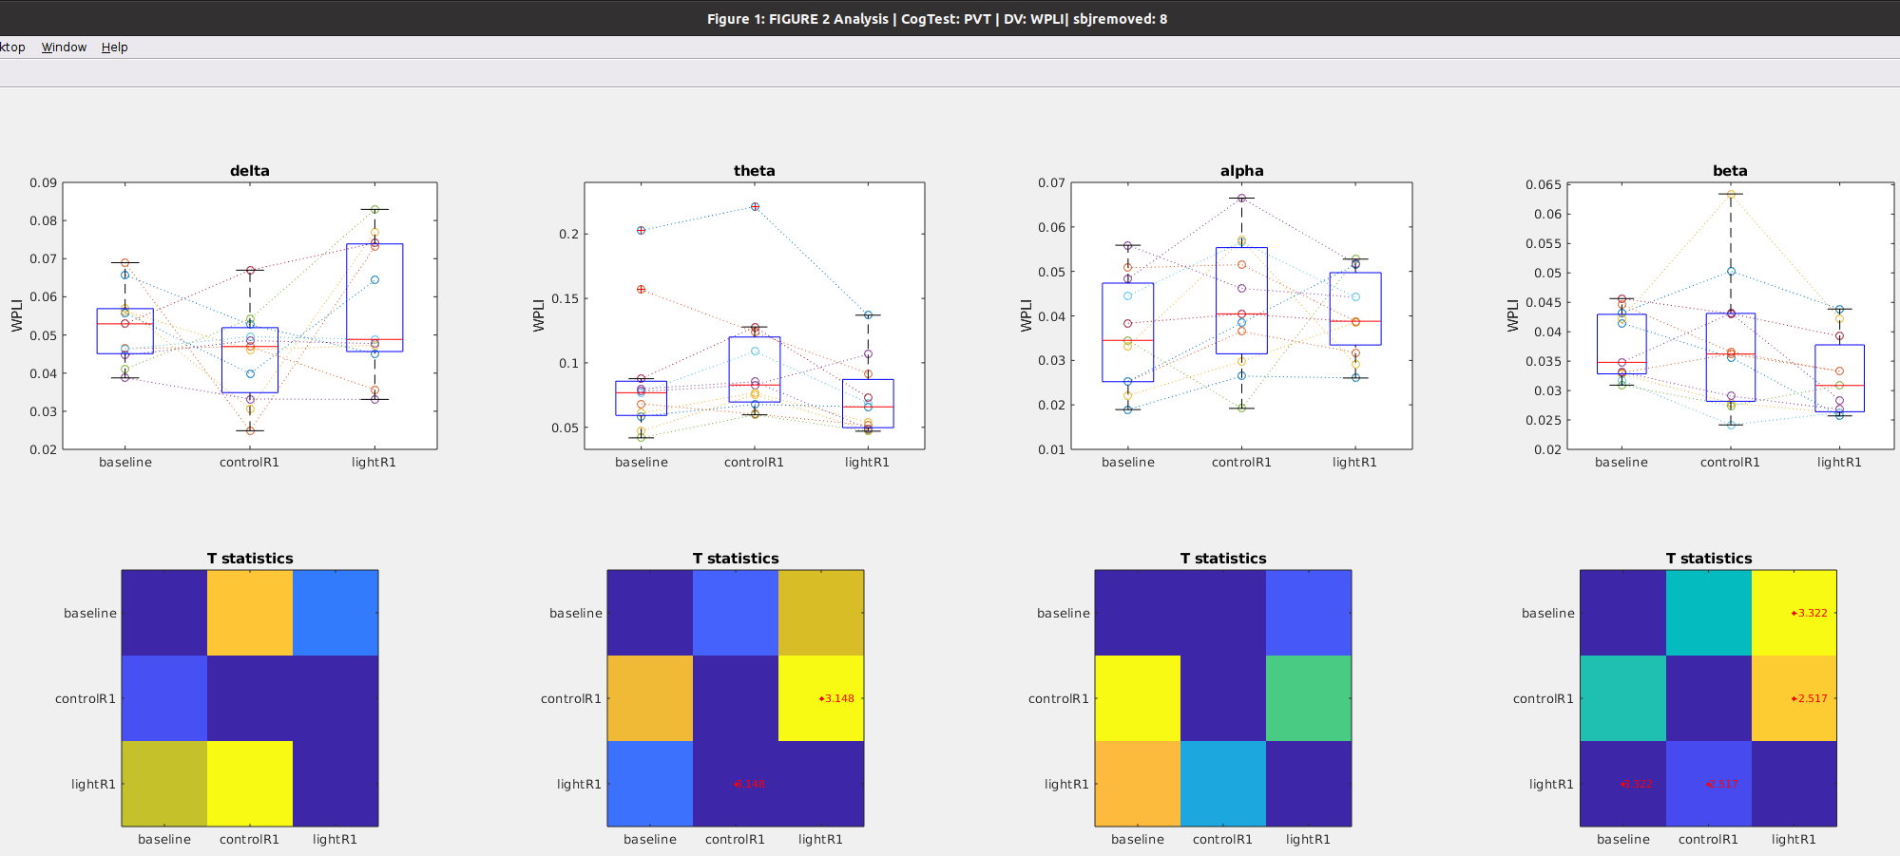

## Eff during PVT

# — — —

# KDT Task Analysis

Notes

* This analysis uses all of the eeg data collected during the KDT task.
* For the KDT task, there was no data for the 12th subject
* Also note that for this analysis I dropped subject 7 because of no baseline data

## Global Power during KDT

### Figure 3a: Time course of **global** after awakening **WITHOUT** blue light exposure

Notes

* No changes in delta band (1st column) or theta band (2nd column)
* Late onset reduction in alpha band (3rd column)
* Immediate reduction in beta band (4rth column)Furthermore, there was no data for the 12 subject

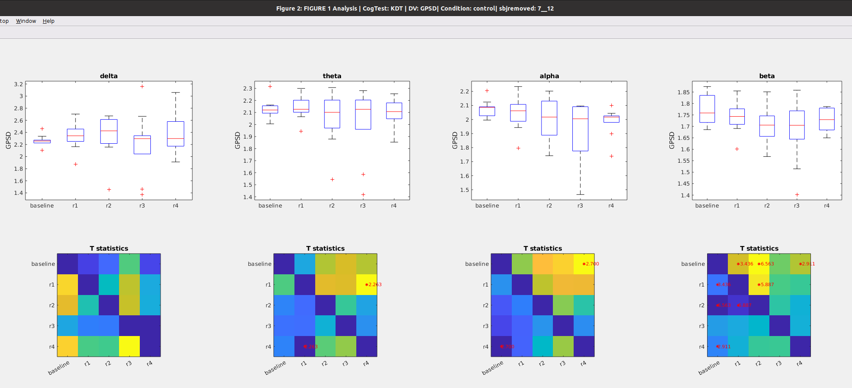

### Figure 3b: Time course of **global** **power** after awakening **WITH** blue light exposure

Notes

* No changes in delta band (1st column) or theta band (2nd column)
* Late onset reduction in alpha band (3rd column)
* Immediate reduction in beta band (4rth column)
* These results roughly similar to the changes seen in the no light condition. Thus blue light doesnt seem to impact the time course of power.

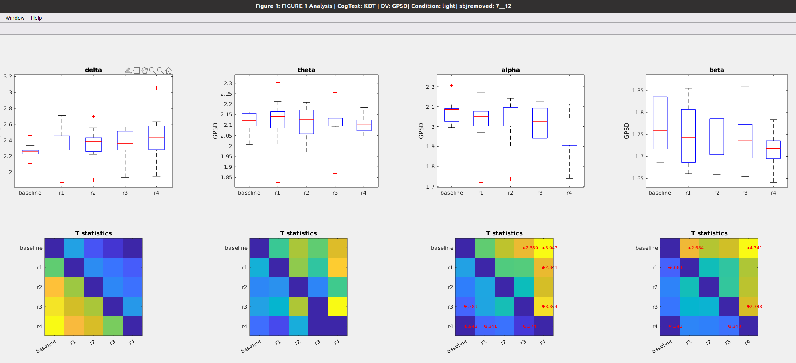

### Figure 3c: **Global power** during preseleep (**baseline**) Vs awakening WITHOUT light exposure (**control_R1**) vs Awakening WITH light exposure (**light_R1**)

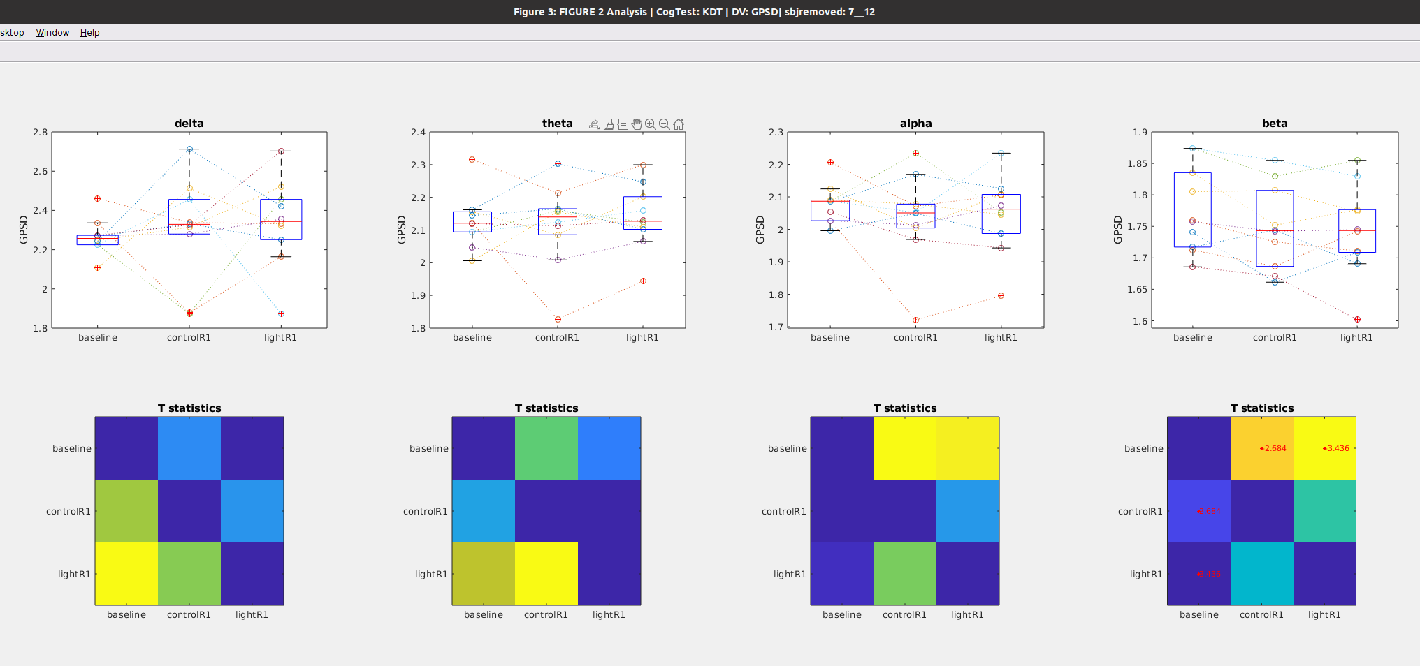

## Path Length during KDT

### Figure 4a: Time course of **Path Length** after awakening **WITHOUT** blue light exposure

Notes

* No changes in path length in any band

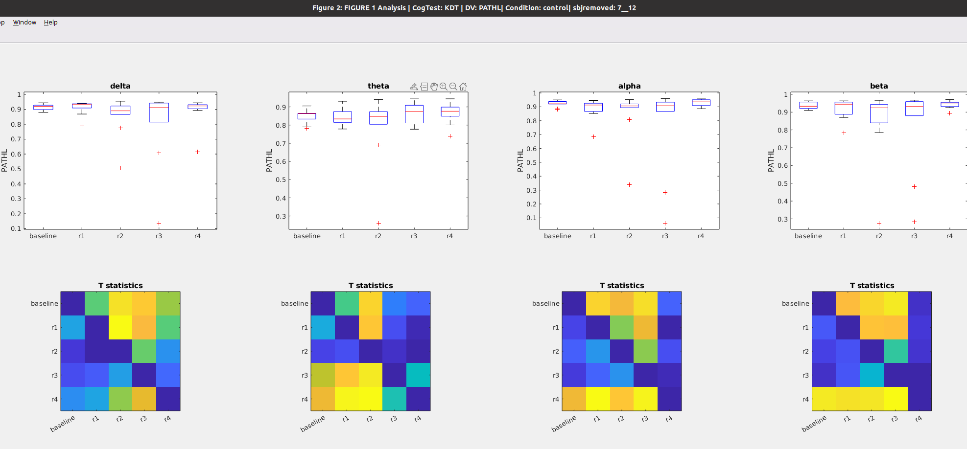

### Figure 4b: Time course of **Path Length** after awakening **WITH blue light exposure**

Notes

* No changes in path length in any band
* These results roughly similar to the changes seen in the no light condition. Thus blue light doesnt seem to impact the time course of power .

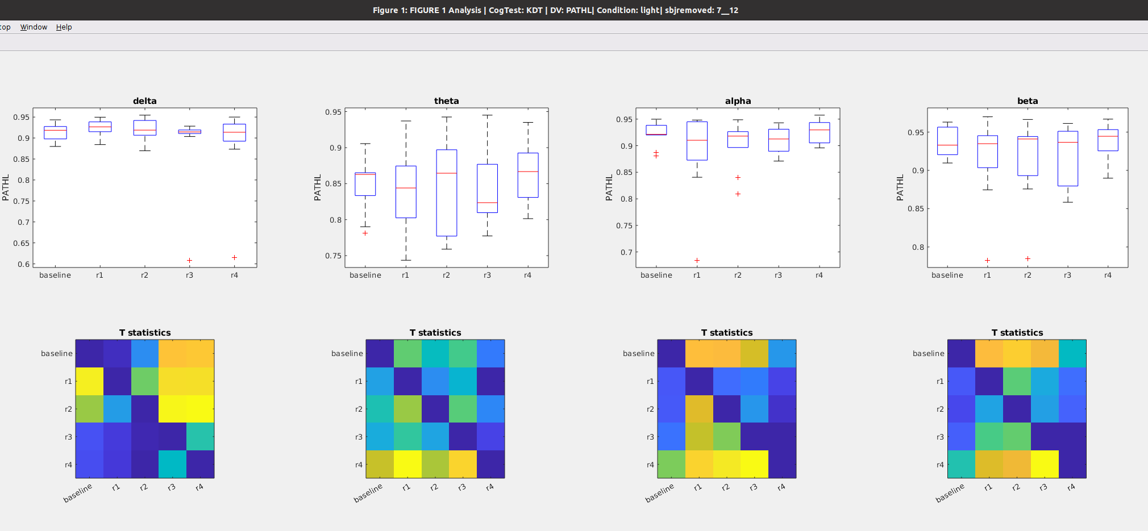

### Figure 4c: **Path Length** during preseleep (**baseline**), Vs awakening WITHOUT light exposure (**control_R1**) vs Awakening WITH light exposure (**light_R1**)

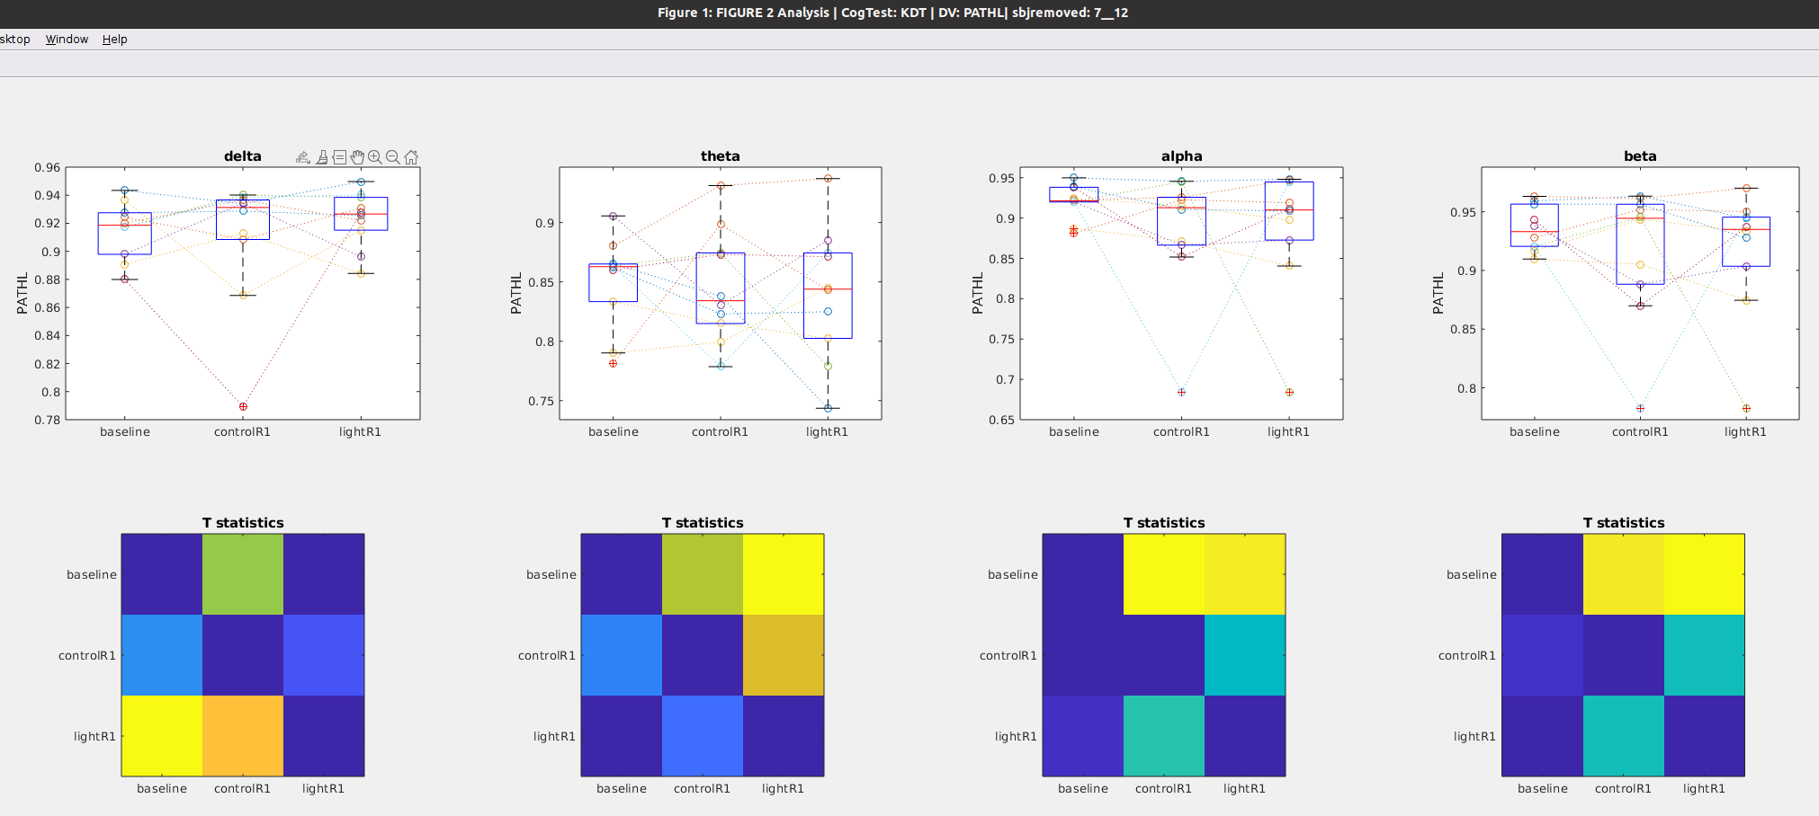

## Clustering during KDT

### Figure 5a: Time course of **Clustering coefficient** after awakening **WITHOUT** blue light exposure

Notes

* No changes in path length in any band

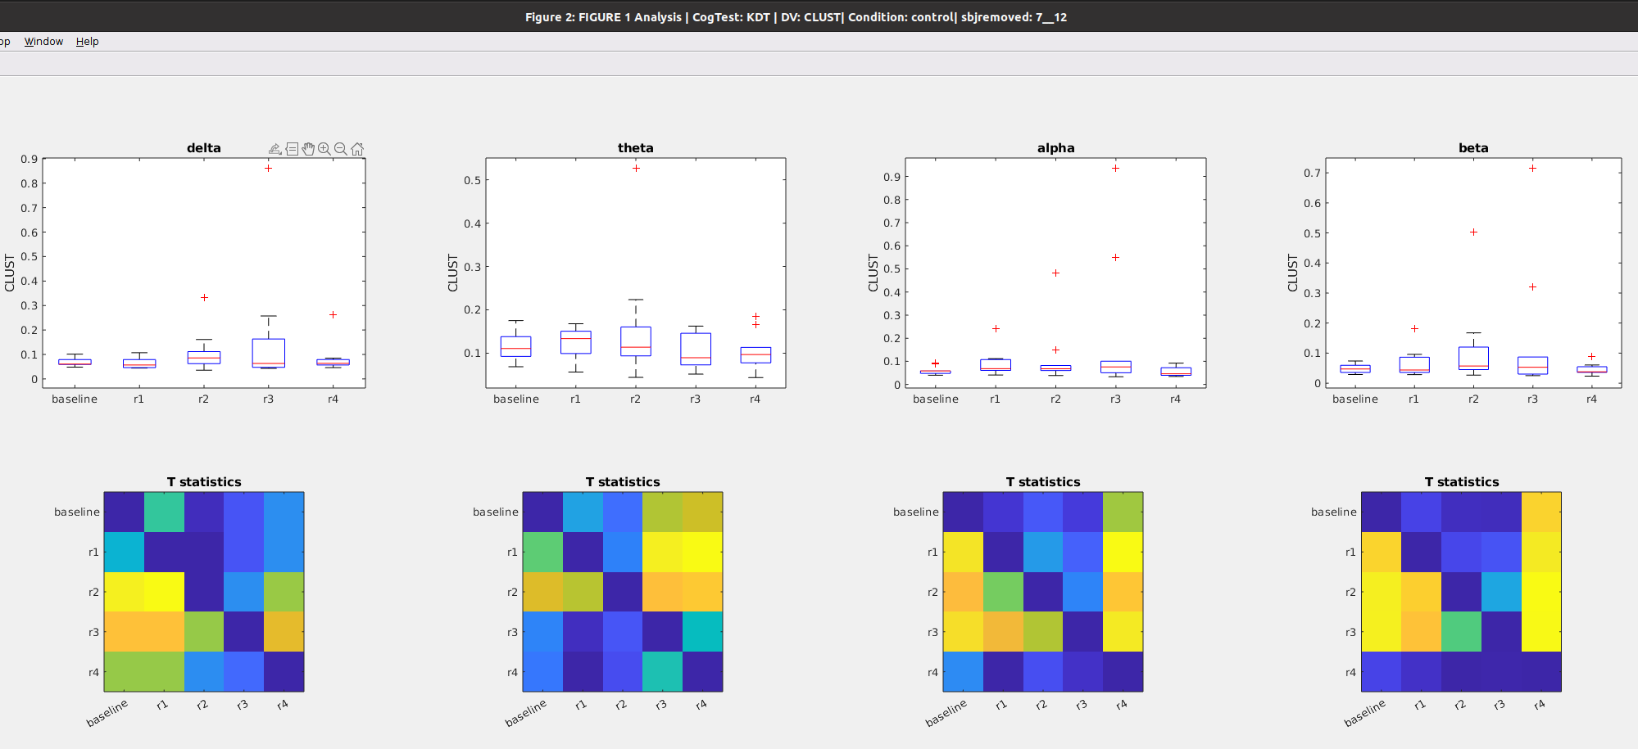

### Figure 5b: Time course of **Clustering coefficient** after awakening **WITH** blue light exposure

Notes

* No changes (from baseline) in path length in any band. (althought there is a reduction in clustering in the 3rd run vs the first run)
* These results roughly similar to the changes seen in the no light condition. Thus blue light doesnt seem to impact the time course of power .

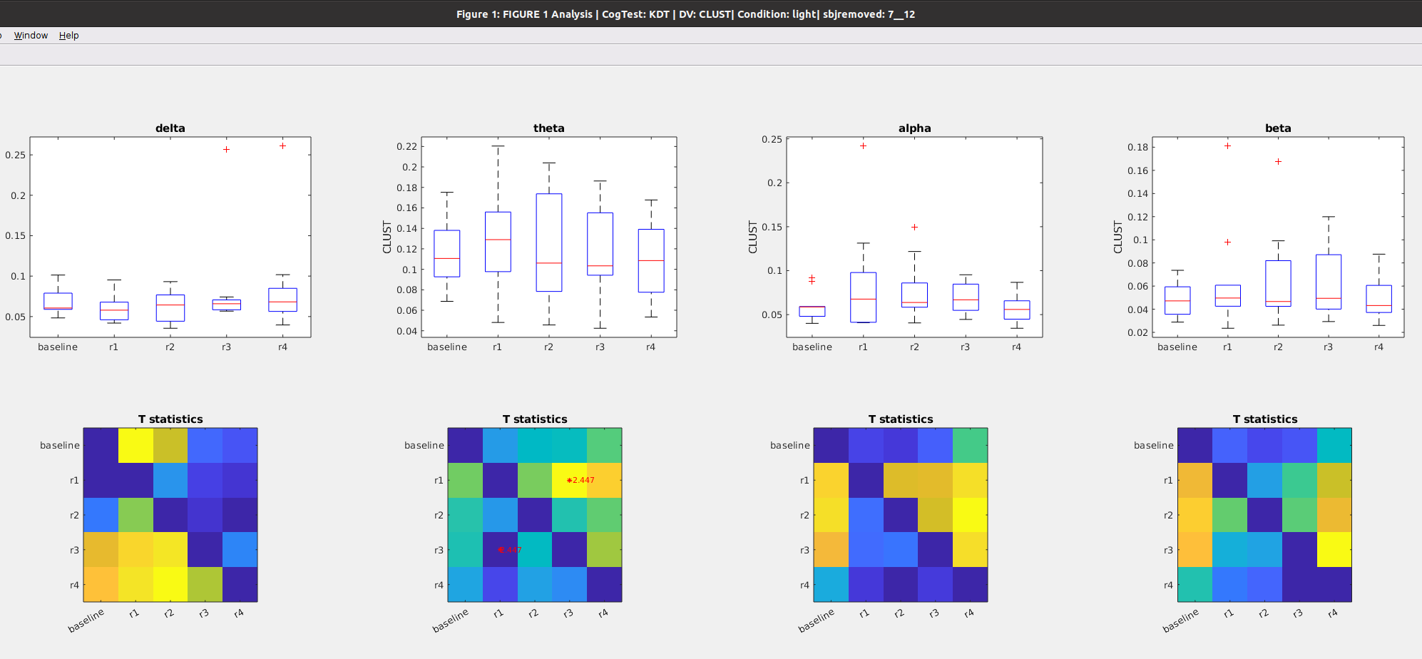

### Figure 5c: **Clustering** during preseleep (**baseline**), Vs awakening WITHOUT light exposure (**control_R1**) vs Awakening WITH light exposure (**light_R1**)

## 

## Betweenness Centrality during KDT

### Figure 6a: Time course of **Betweenness** after awakening **WITHOUT** blue light exposure

Notes

* No changes in delta betweenness (1rst column), alpha betweenness (1rst column),nor beta betweenness (1rst column) from baselin
* Reduction in alpha from baseline at the 4rth time point

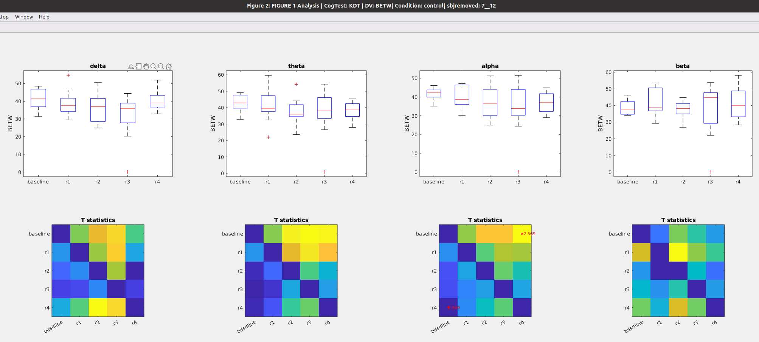

### Figure 6b: Time course of **Betweenness** after awakening **WITH blue light exposure**

Notes

* No changes in delta betweenness (1rst column), alpha betweenness (1rst column),nor beta betweenness (1rst column) from baseline
* Reduction in alpha from baseline at the immediately and again at the 4rth time point

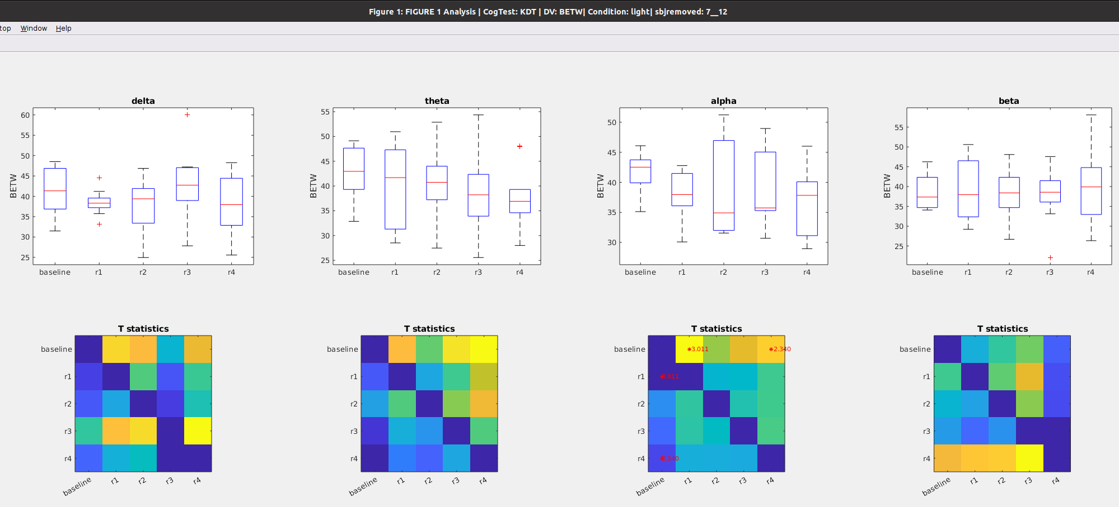

### Figure 6c: **Betweennes** during preseleep (**baseline**) Vs awakening WITHOUT light exposure (**control_R1**) vs Awakening WITH light exposure (**light_R1**)

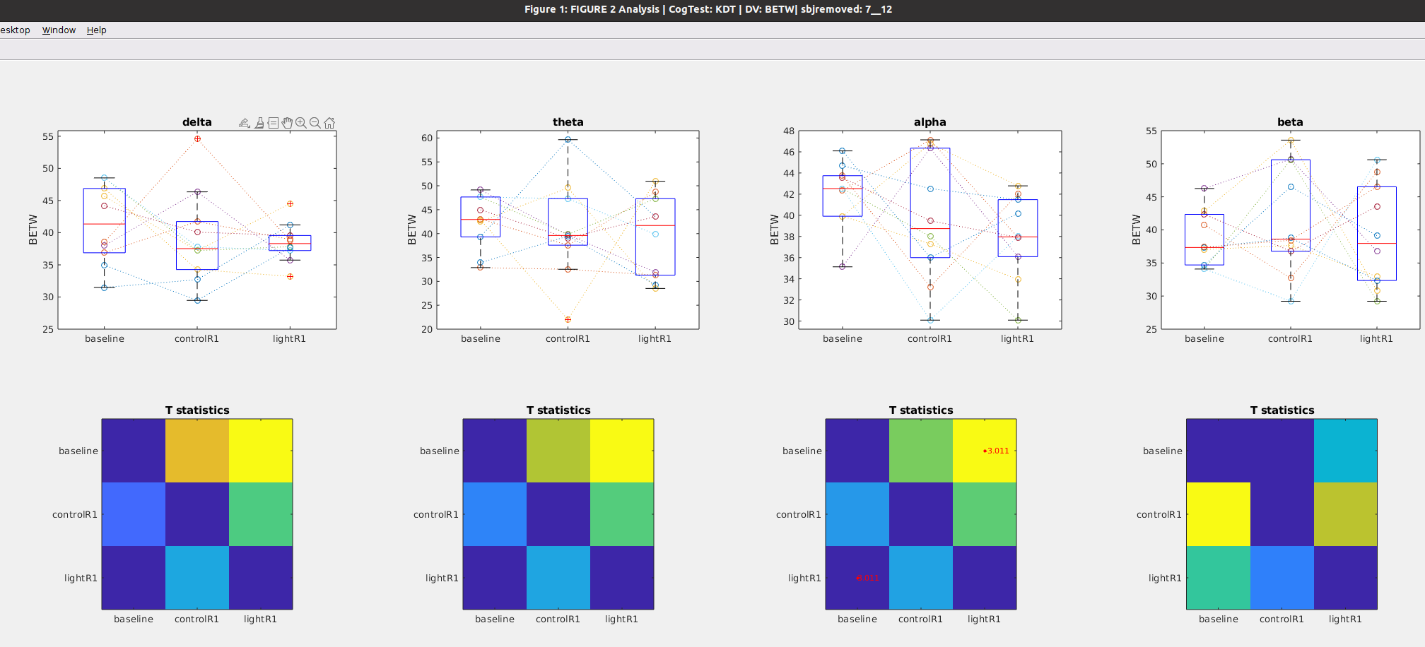

## WPLI during KDT

### Figure 7a: Time course of **WPLI** after awakening **WITHOUT** blue light exposure

Notes

* No changes in delta wpli after awakening (see 1rst column)
* Immediate Increase in theta wpli after awakening but quickly recovers by the second run (see 2nd column)
* Delayed increase in alpha wpli that recovers by the fourth run (see 3rd column)
* Delayed increase in beta wpli (on the second run) that does not recover (see 4rth column)

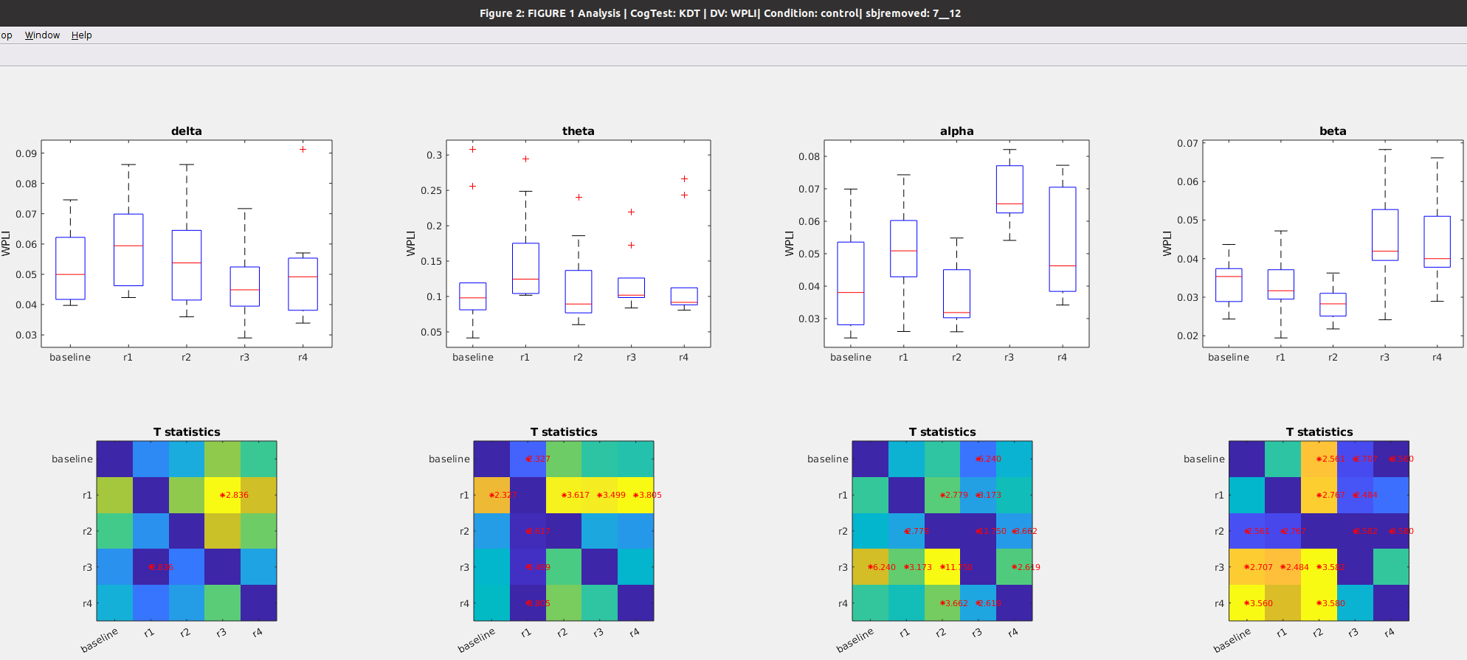

### Figure 7b: Time course of **WPLI** after awakening **WITH** blue light exposure

Notes

* Alpha band shows a delayed reduction from baseline, at the 4rth timepoint
  + This is different from the no-light condition, where there are no changes in alpha band
* Theta wpli increases at the second time point, but returns back to baseline levels by the third time point
* Alpha band increases from baseline at the second time point and does not recover,
  + In contrast, in the no light condition, alpha wpli increases at a later time and recovers immediately

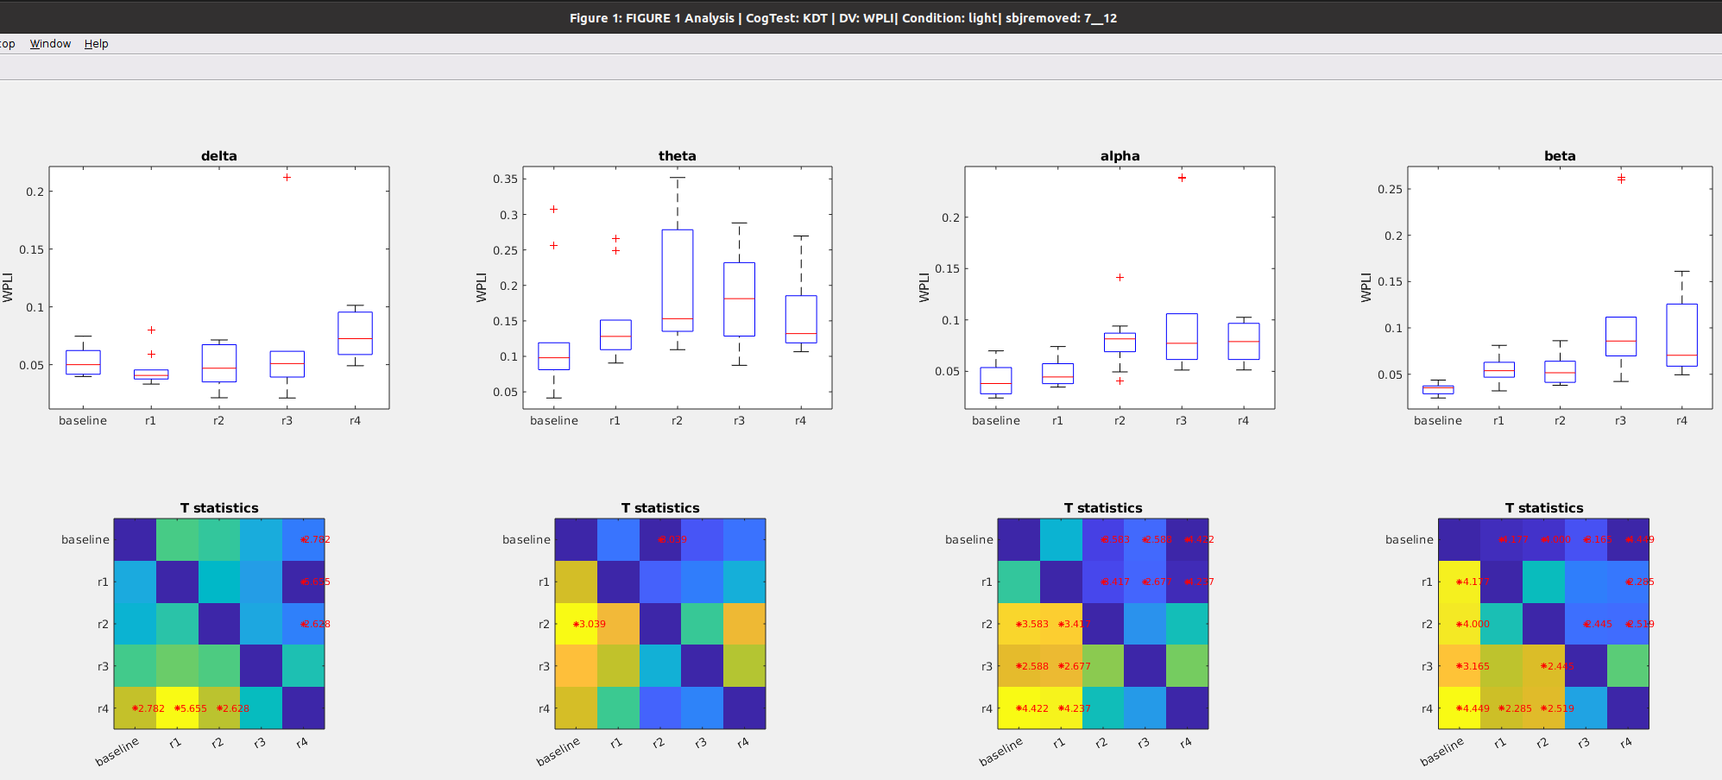

### Figure 7c: **WPLI** during preseleep (**baseline**) Vs awakening WITHOUT light exposure (**control_R1**) vs Awakening WITH light exposure (**light_R1**)

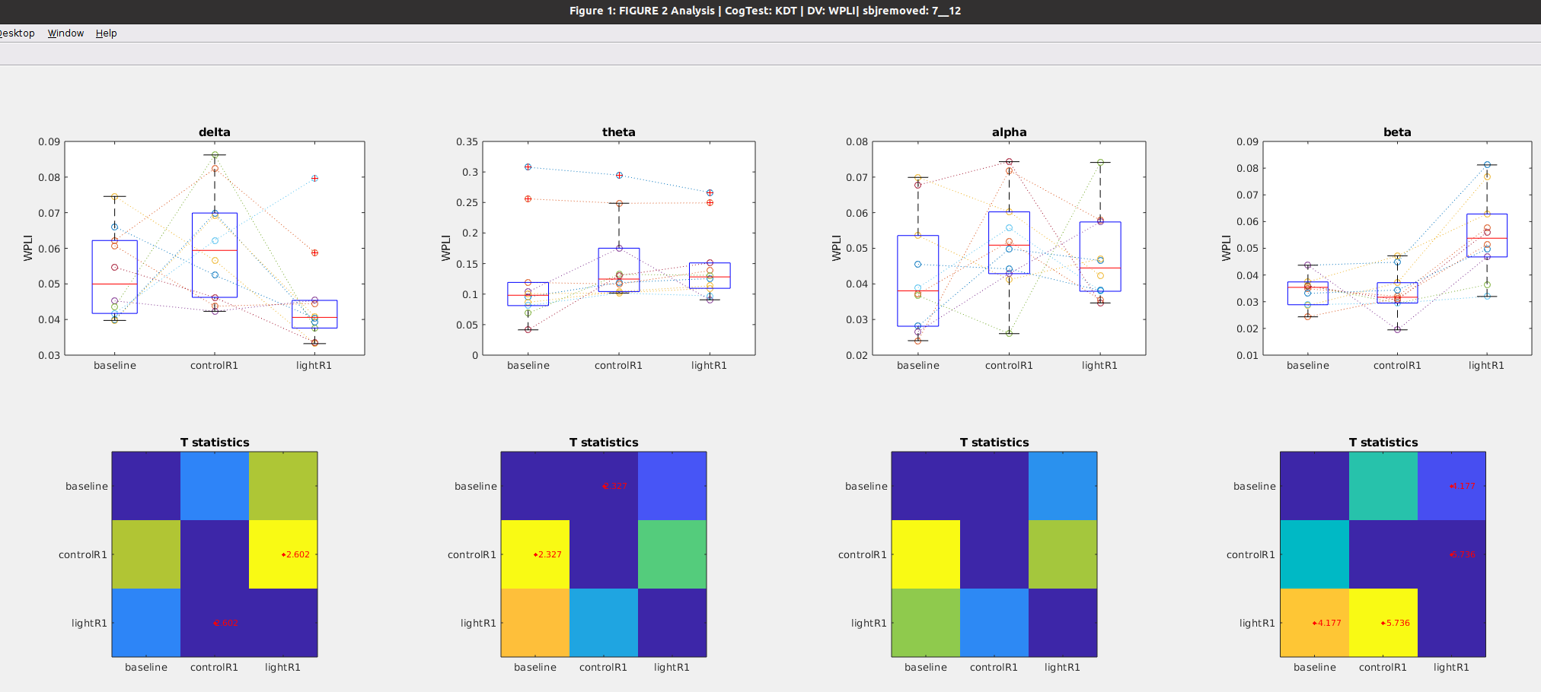

# Math Task

Notes

* This analysis uses all of the eeg data collected during the Math task.
* For the math task data, had to removed subjects 5, 8 and 10 for missing data, so n = 9

## Global Power during Math

### Figure 8a: Time course of **global** after awakening **WITHOUT** blue light exposure

Notes

* Theta, alpha and beta global power all decrease by the second time point, but return to baseline levels by the 4rth time point
* No changes in the delta band (1rst column)

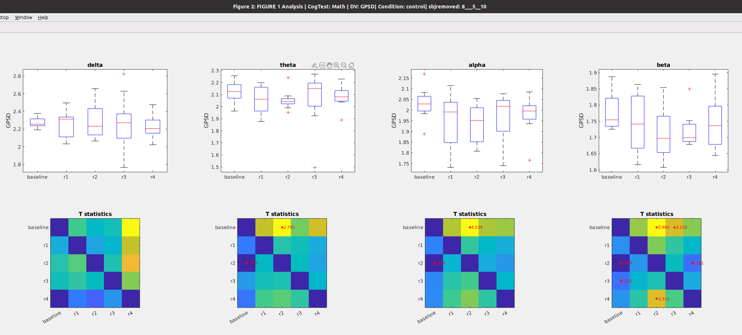

### Figure 8b: Time course of **global** **power** after awakening **WITH** blue light exposure

Notes

* No changes in delta band with blue light exposure, same as when no-exposure
* No changes in theta band with blue light exposure, different from the reduction observed with no-exposure
* In the alpha band, when exposed to light a reduction occurs at a later time point and does not revert back to baseline, compared to the no light condition,
* In the beta band, reduction is observed immediately after awakening

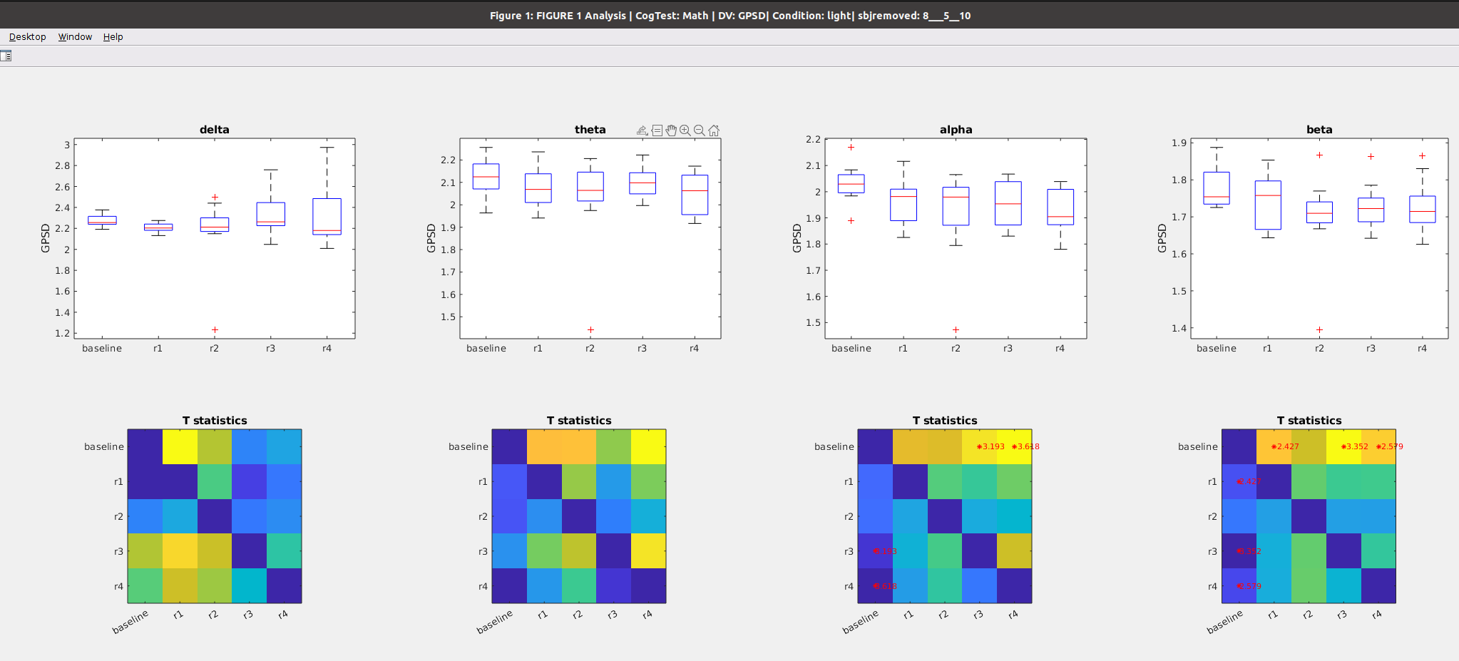

### Figure 8C: **Global power** during preseleep (**baseline**) Vs awakening WITHOUT light exposure (**control_R1**) vs Awakening WITH light exposure (**light_R1**)

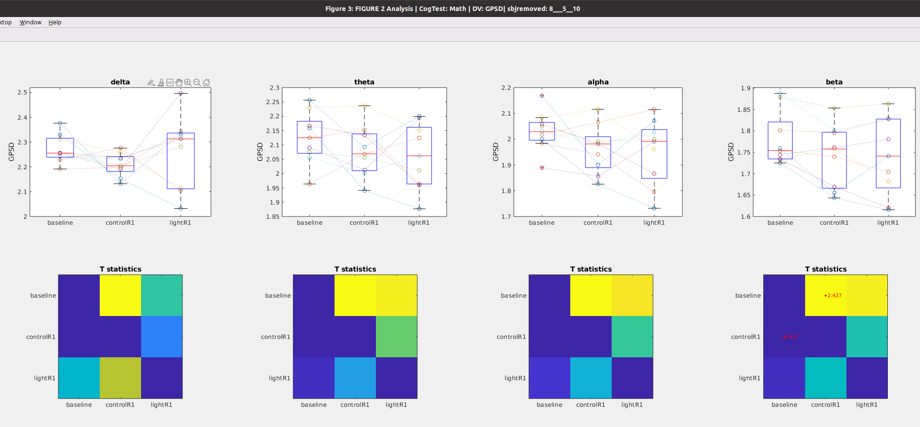

## 

## Path Length during Math Task

### Figure 9a: Time course of **Path Length** after awakening **WITHOUT blue light exposure**

Notes

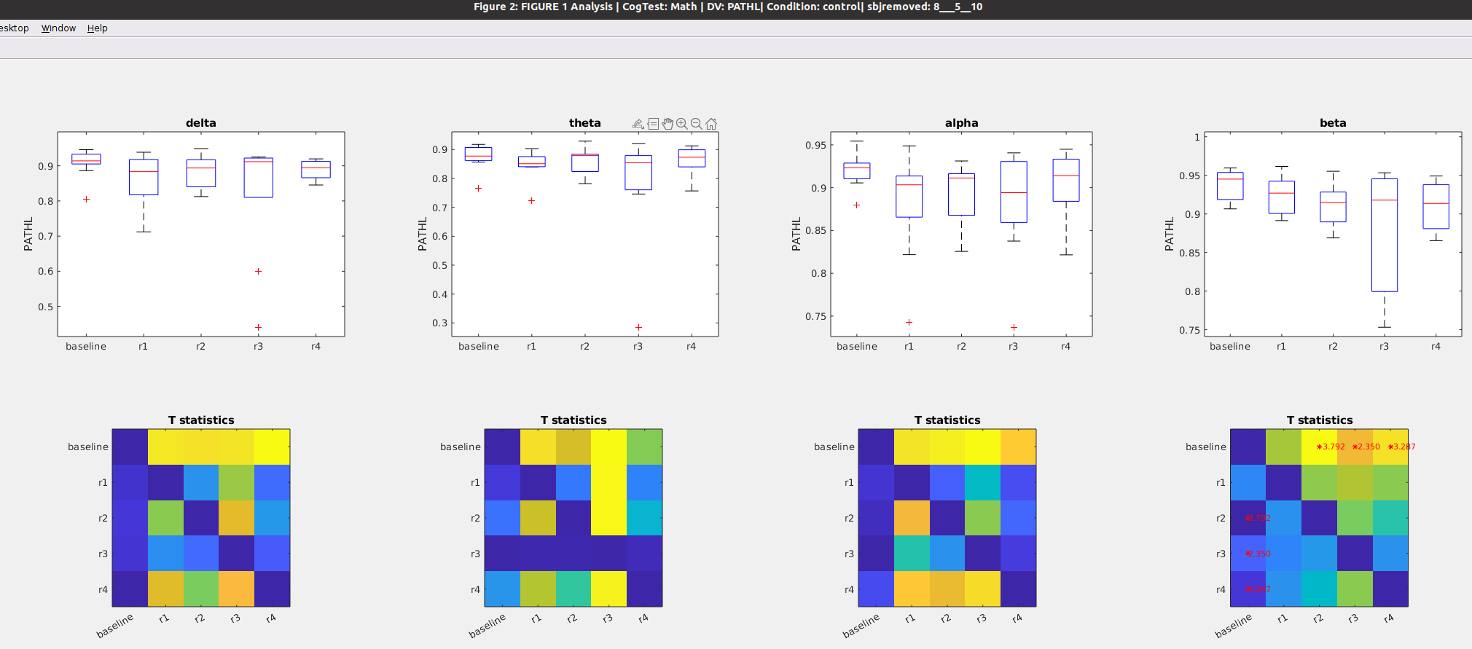

### Figure 9b: Time course of **Path Length** after awakening **WITH blue light exposure**

Notes

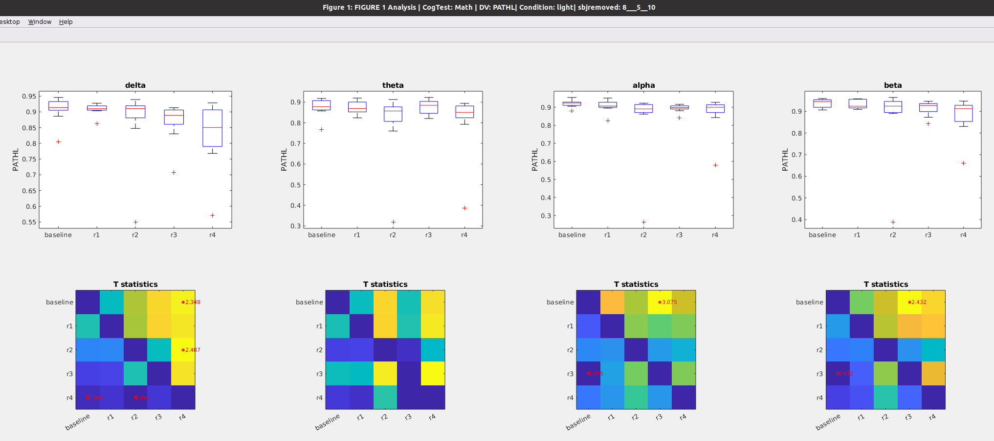

### Figure 9C: **Path Length** during preseleep (**baseline**) Vs awakening WITHOUT light exposure (**control_R1**) vs Awakening WITH light exposure (**light_R1**)

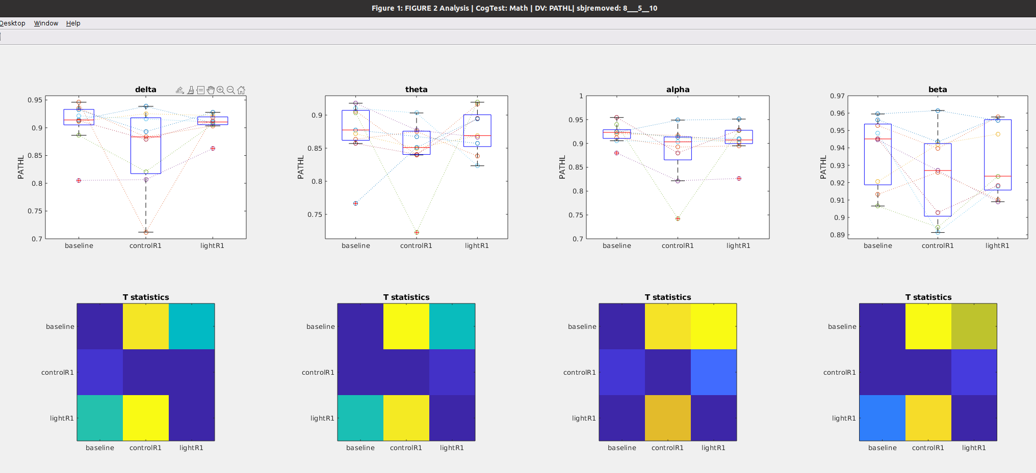

## Clustering during Math

### Figure 10a: Time course of **Clustering coefficient** after awakening **WITHOUT blue light exposure**

Notes

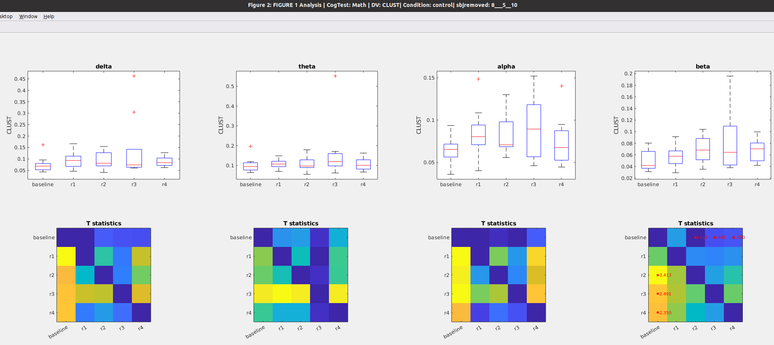

### Figure 10b: Time course of **Clustering coefficient** after awakening **WITH blue light exposure**

Notes

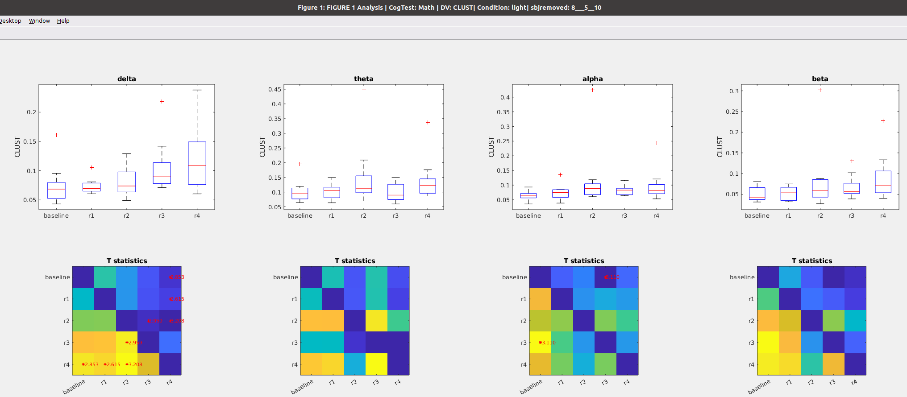

### Figure 10C: **Clustering** during preseleep (**baseline**) Vs awakening WITHOUT light exposure (**control_R1**) vs Awakening WITH light exposure (**light_R1**)

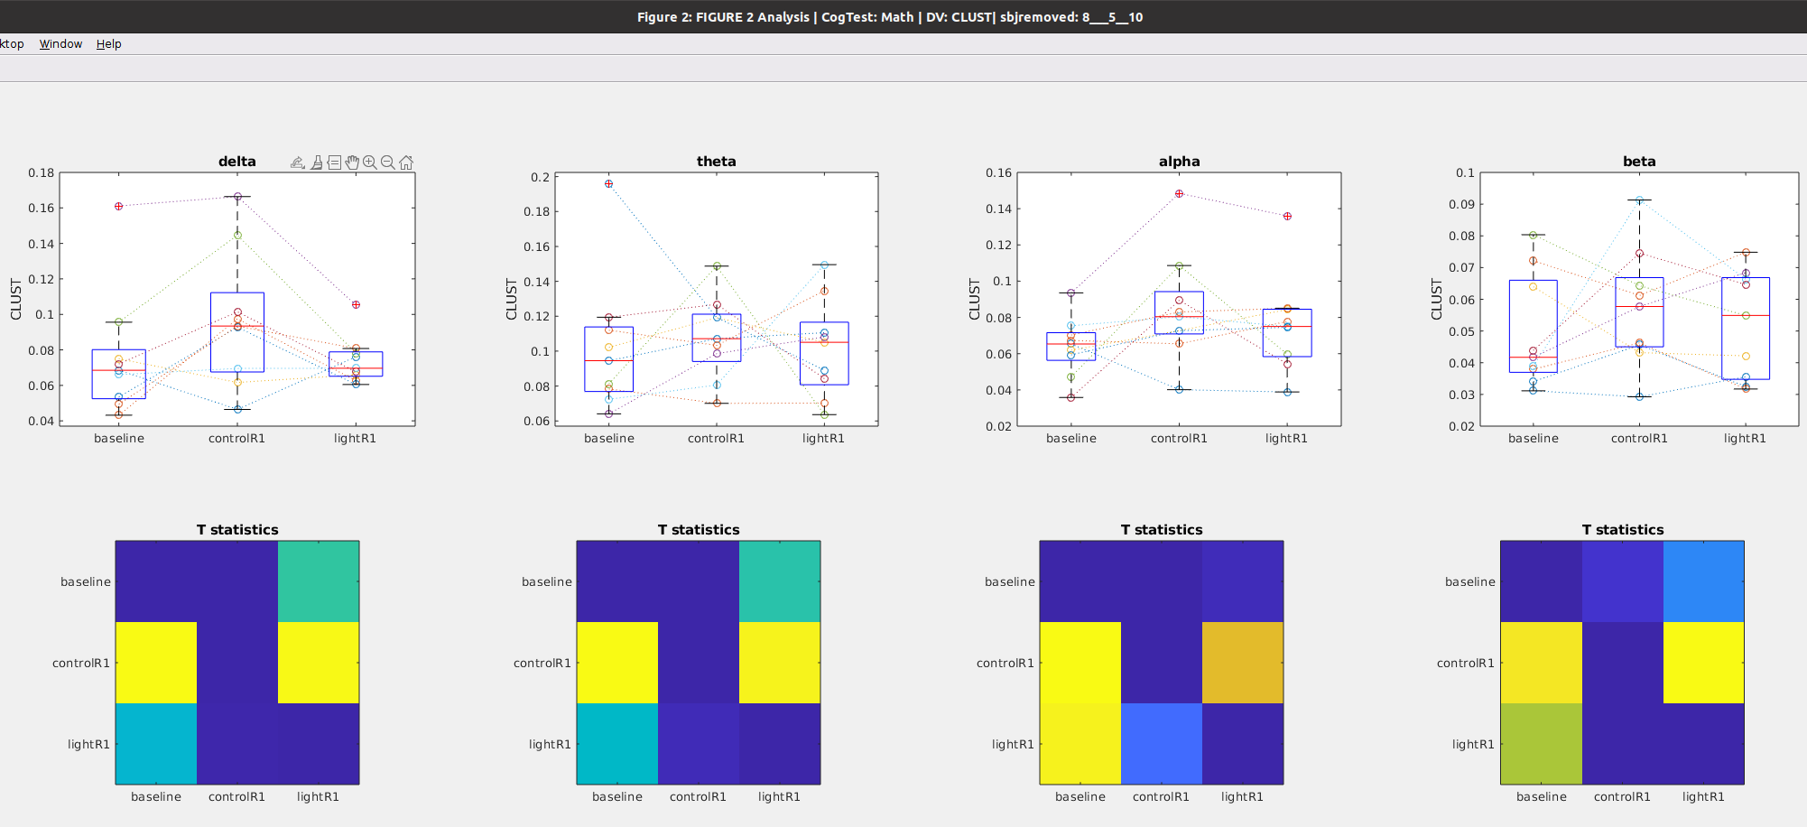

## Betweenness Centrality during Math

### Figure 11a: Time course of **Betweenness** after awakening **WITHOUT** blue light exposure

Notes

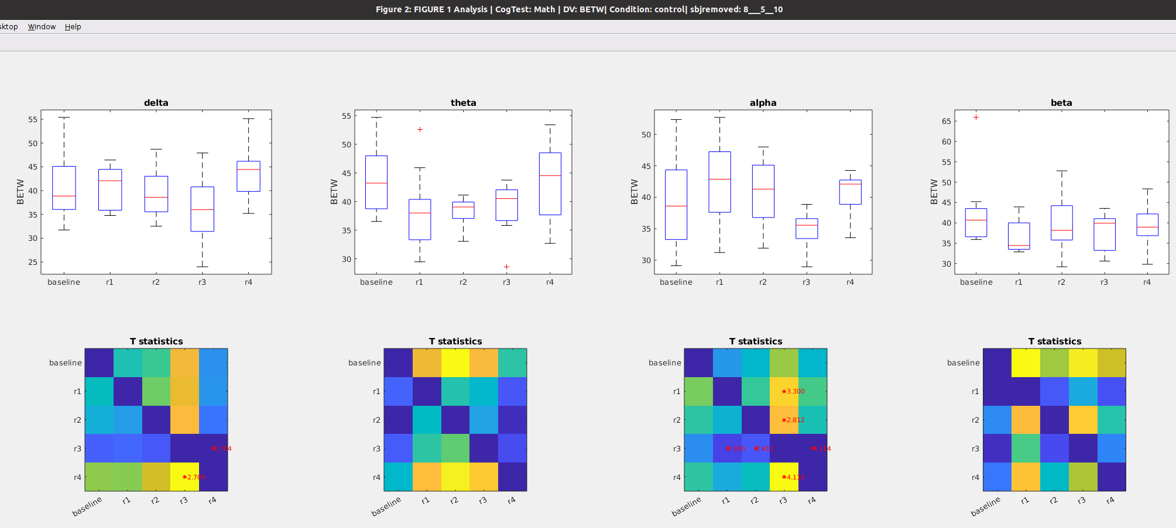

### Figure 11b: Time course of **Betweenness** after awakening **WITH blue light exposure**

Notes

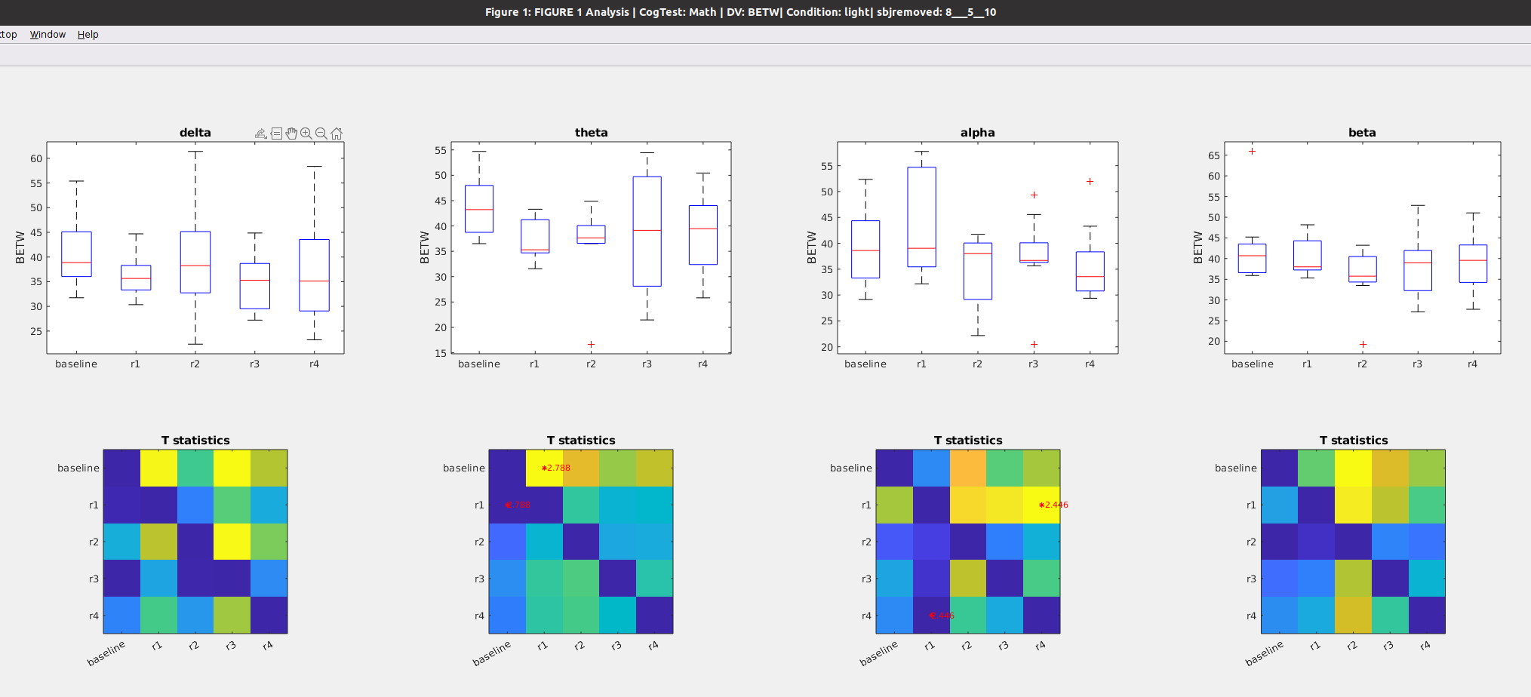

￼￼￼

### Figure 11c: **Betweennes** during preseleep (**baseline**) Vs awakening WITHOUT light exposure (**control_R1**) vs Awakening WITH light exposure (**light_R1**)

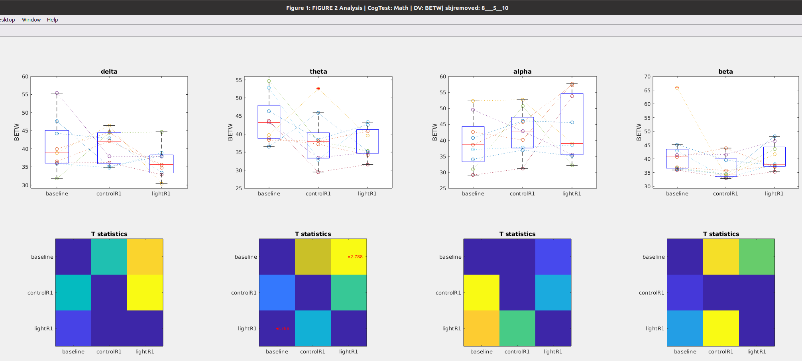

## WPLI during Math

### Figure 12a: Time course of **WPLI** after awakening **WITHOUT** blue light exposure

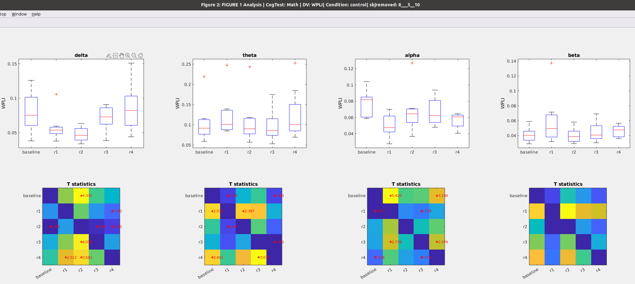

### Figure 12b: Time course of **WPLI** after awakening **WITH** blue light exposure

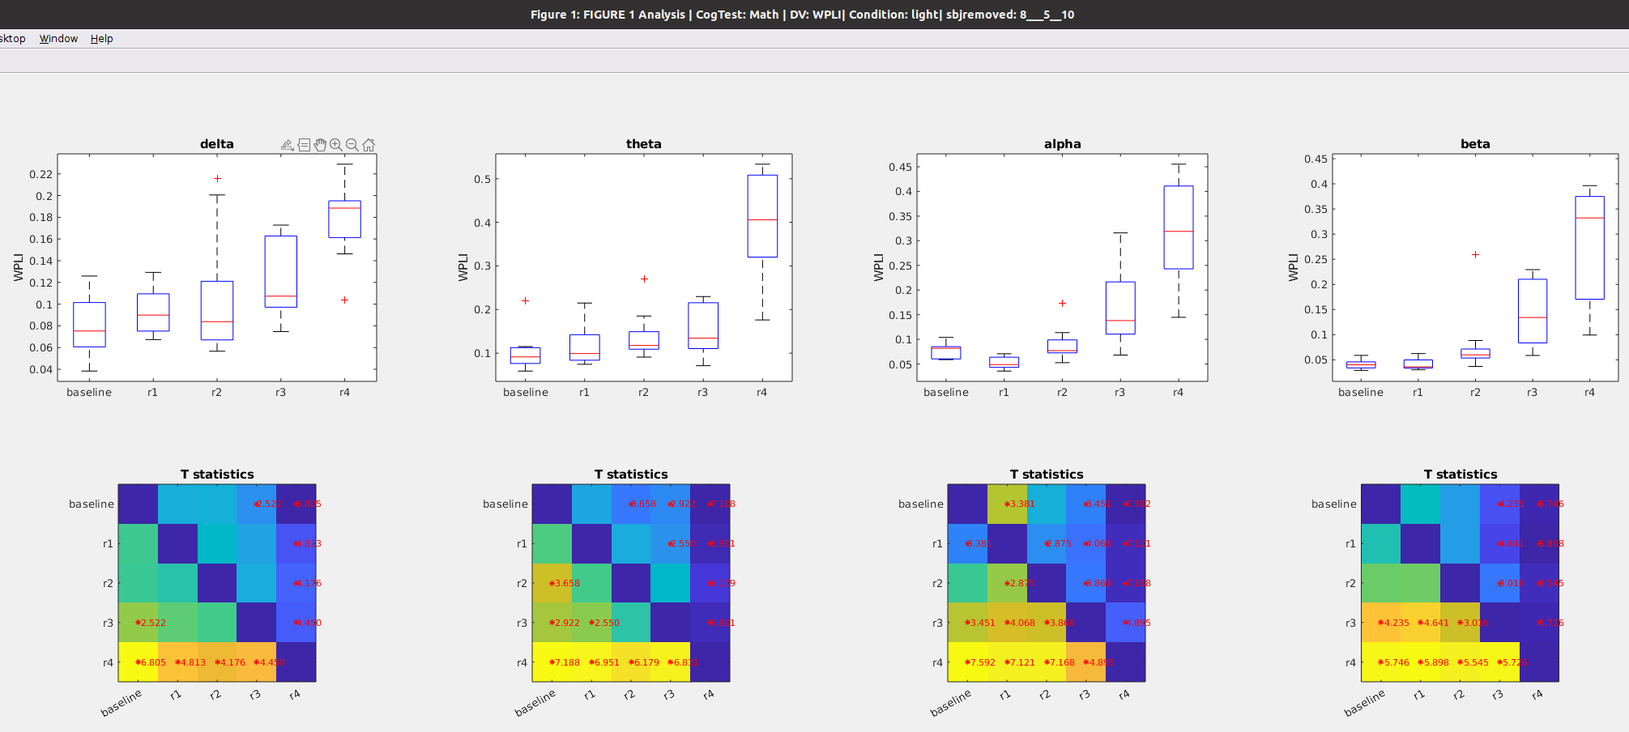

### Figure 12C: **WPLI** during preseleep (**baseline**) Vs awakening WITHOUT light exposure (**control_R1**) vs Awakening WITH light exposure (**light_R1**)

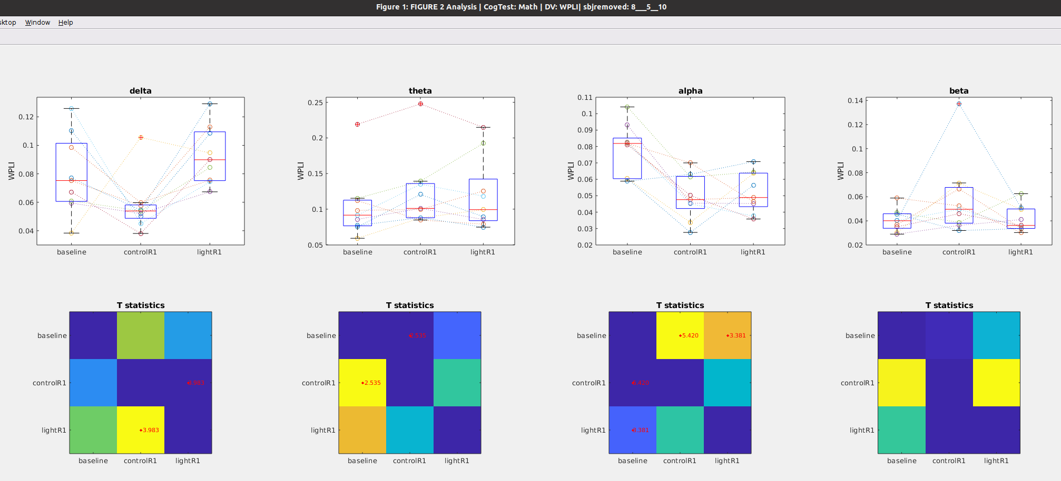

# GoNogo Task

Notes

* This analysis uses all of the eeg data collected during the Math task.
* Removed subjects 5, 7 and 8 and 10 for missing data, so n = 9

## Global Power during GoNogo Task

### Figure 13a: Time course of **global** **Power** after awakening **WITHOUT** blue light exposure

Notes

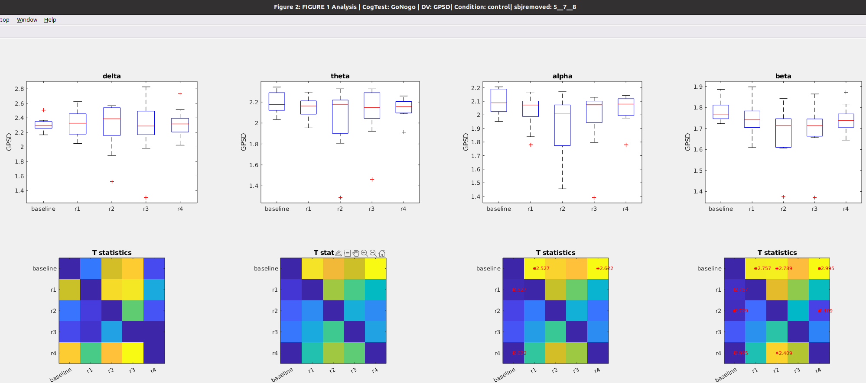

### Figure 13b: Time course of **global** **power** after awakening **WITH** blue light exposure

Notes

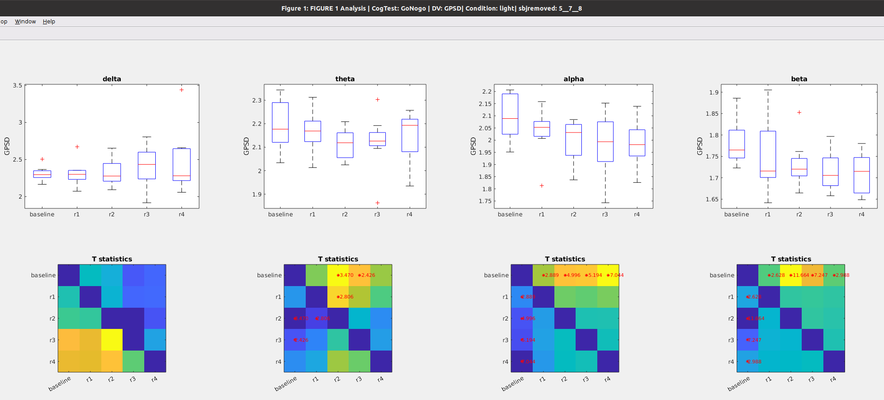

### Figure 13C: **Global power** during preseleep (**baseline**) Vs awakening WITHOUT light exposure (**control_R1**) vs Awakening WITH light exposure (**light_R1**)

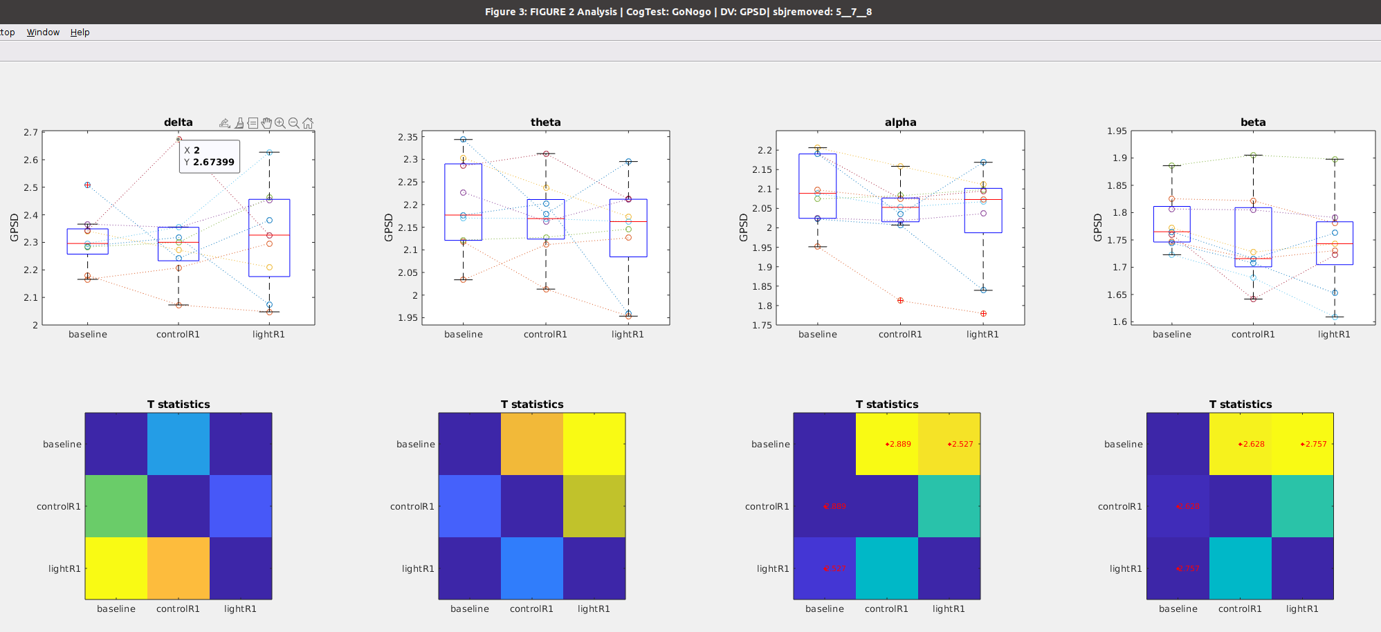

## Path Length during GoNogo Task Task

### Figure 14a: Time course of **Path Length** after awakening **WITHOUT blue light exposure**

Notes

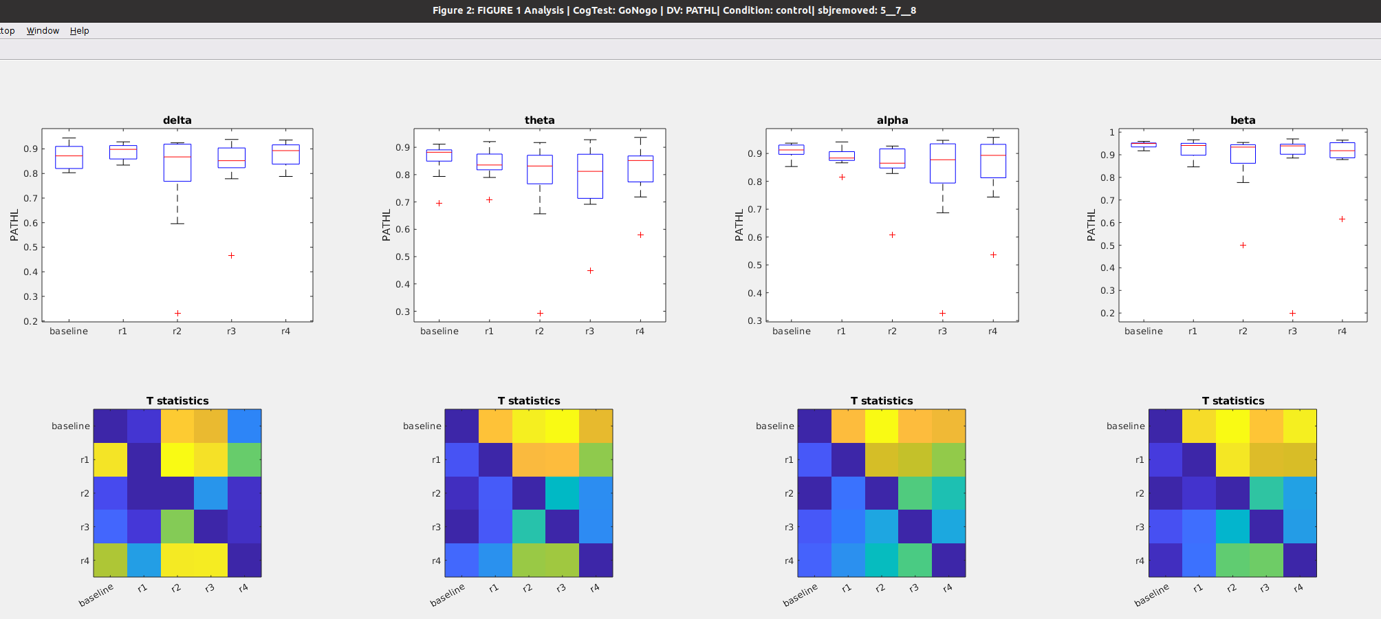

### Figure 14b: Time course of **Path Length** after awakening **WITH blue light exposure**

Notes

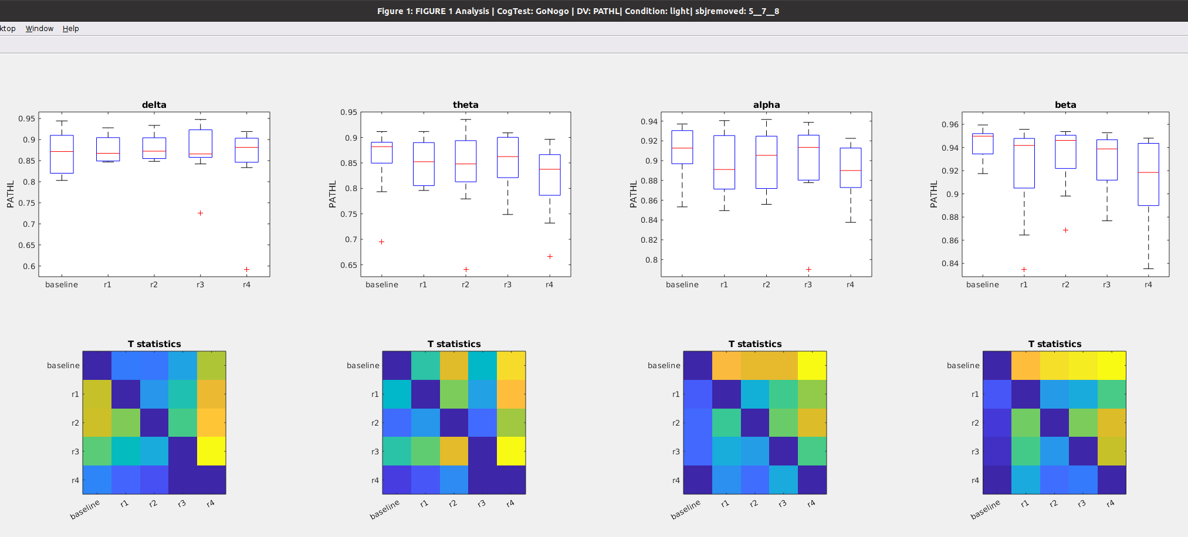

### Figure 14c: **Path Length** during preseleep (**baseline**), Vs awakening WITHOUT light exposure (**control_R1**) vs Awakening WITH light exposure (**light_R1**)

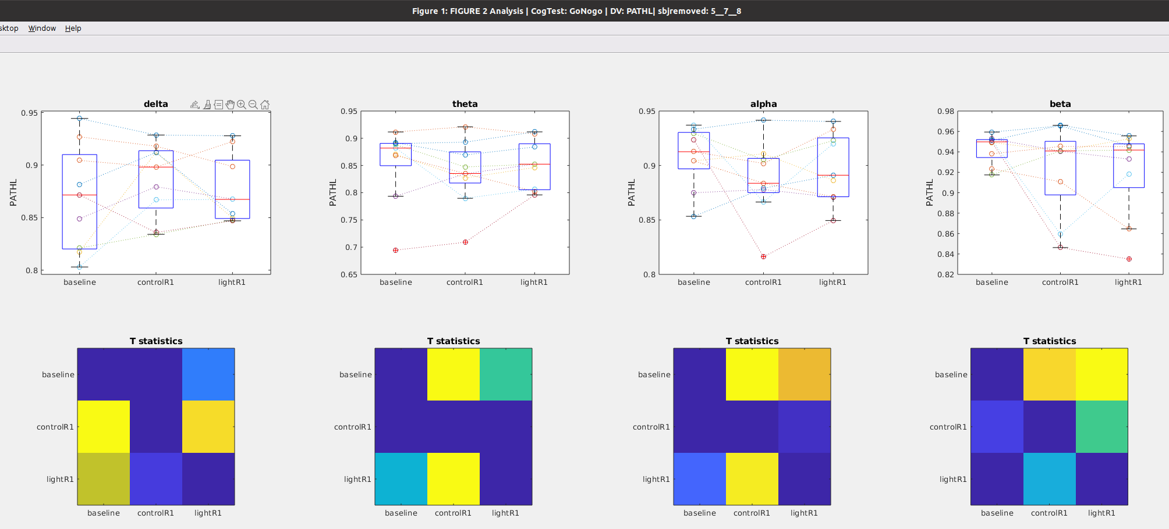

## Clustering during GoNogo Task

### Figure 15a: Time course of **Clustering coefficient** after awakening **WITHOUT blue light exposure**

Notes

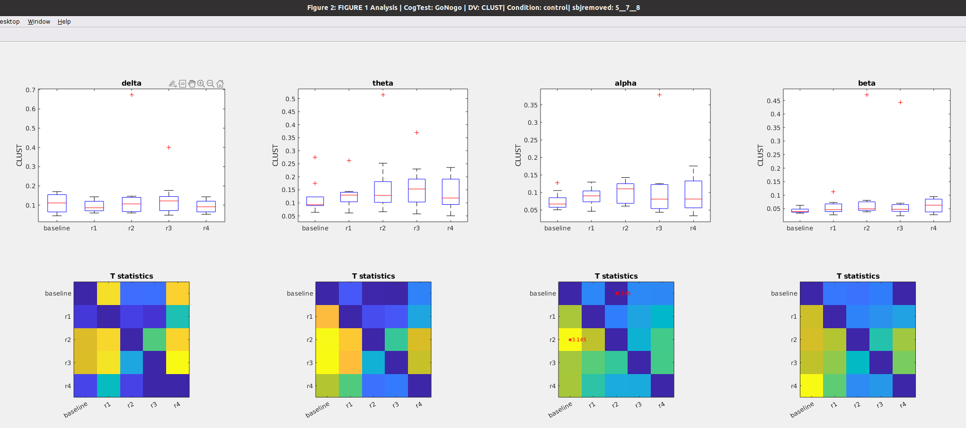

### Figure 15b: Time course of **Clustering coefficient** after awakening **WITH blue light exposure**

Notes

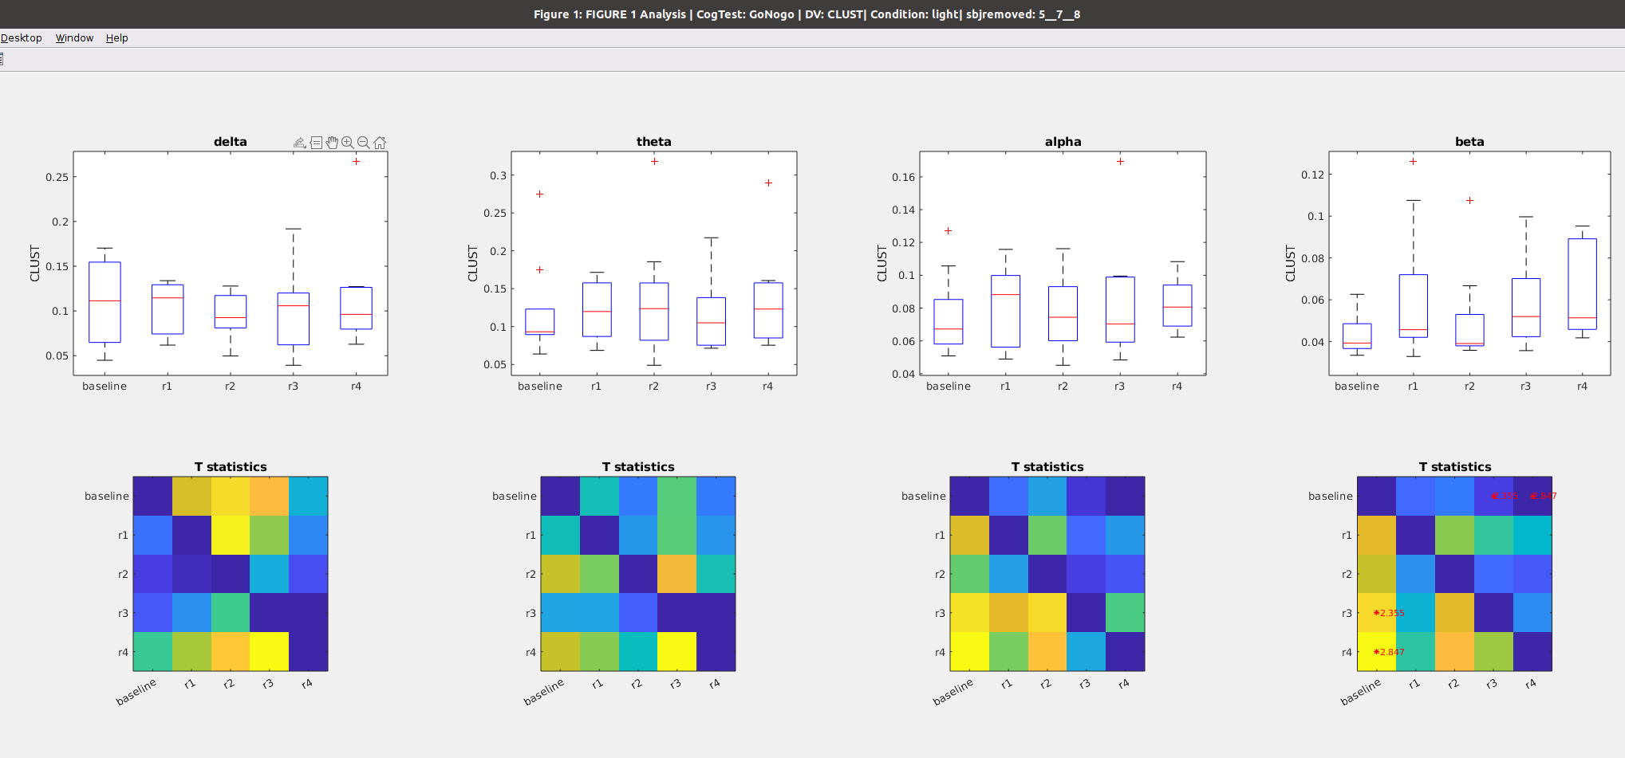

### Figure 15C: **Clustering** during preseleep (**baseline**), Vs awakening WITHOUT light exposure (**control_R1**) vs Awakening WITH light exposure (**light_R1**)

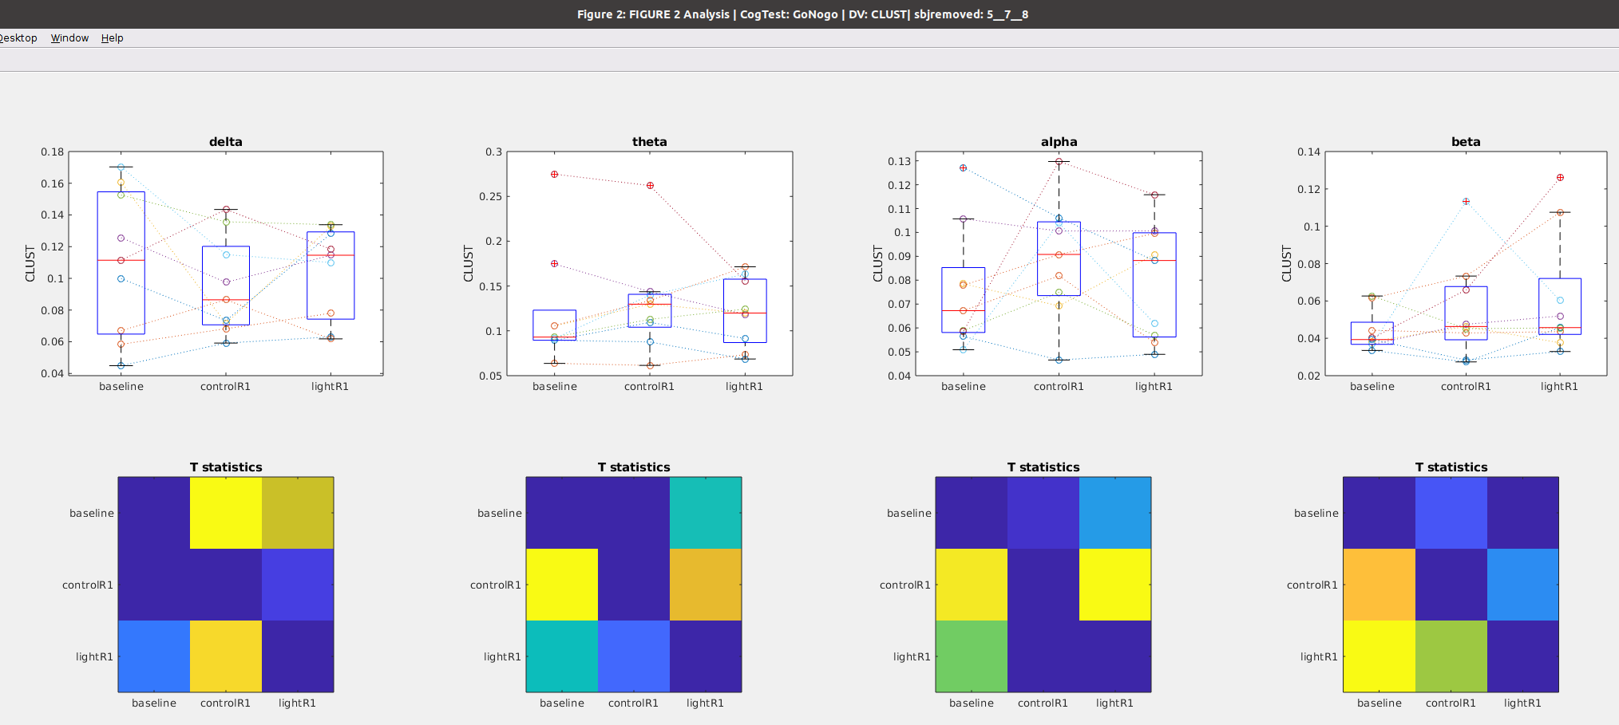

## Betweenness Centrality during GoNogo Task

### Figure 16a: Time course of **Betweenness** after awakening **WITHOUT** blue light exposure

Notes

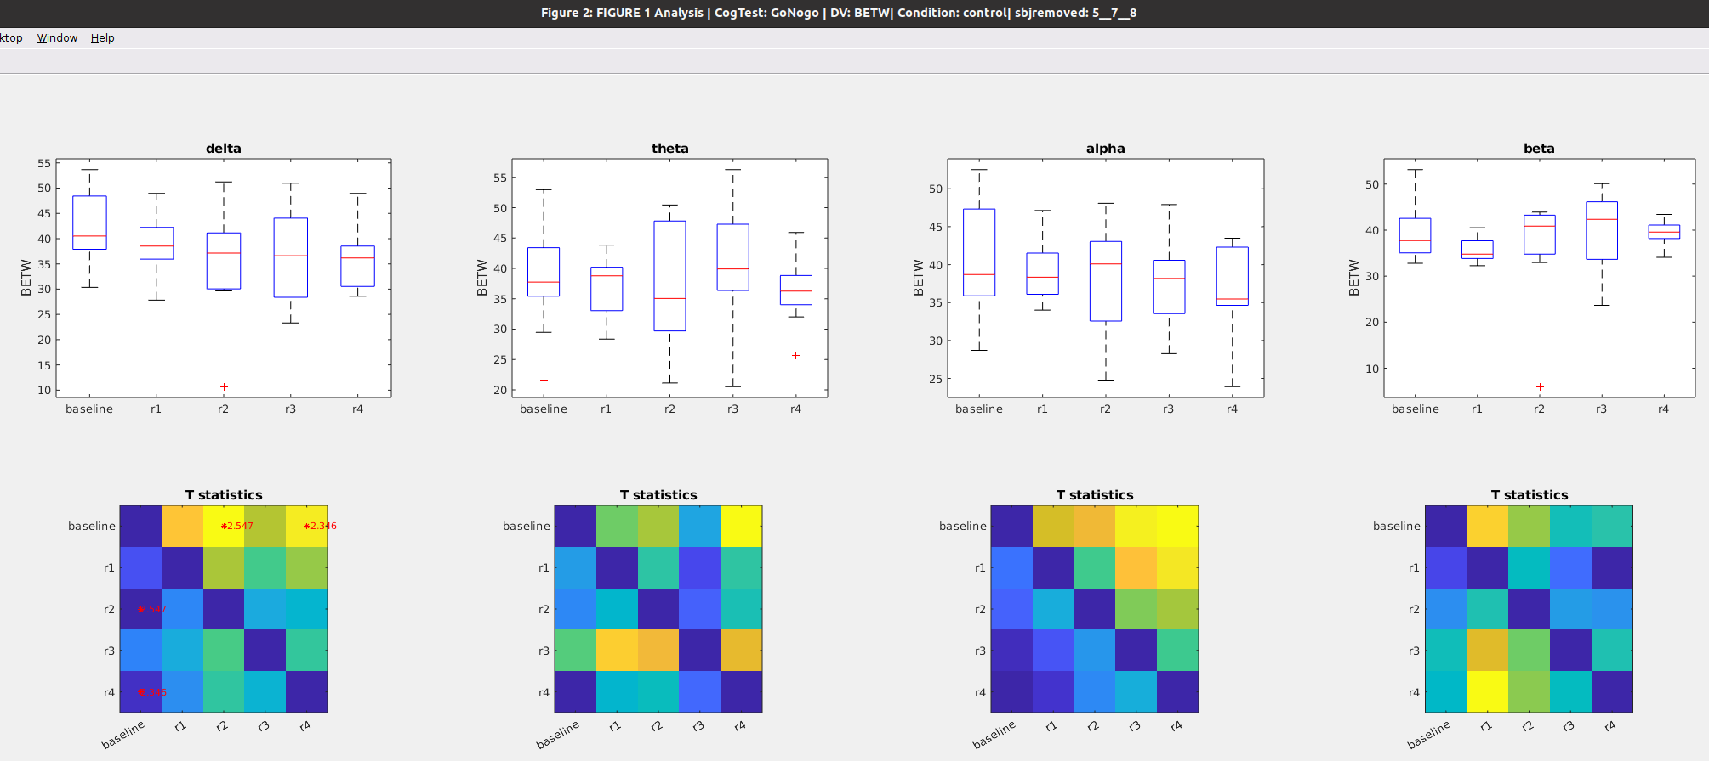

### Figure 16b: Time course of **Betweenness** after awakening **WITH blue light exposure**

Notes

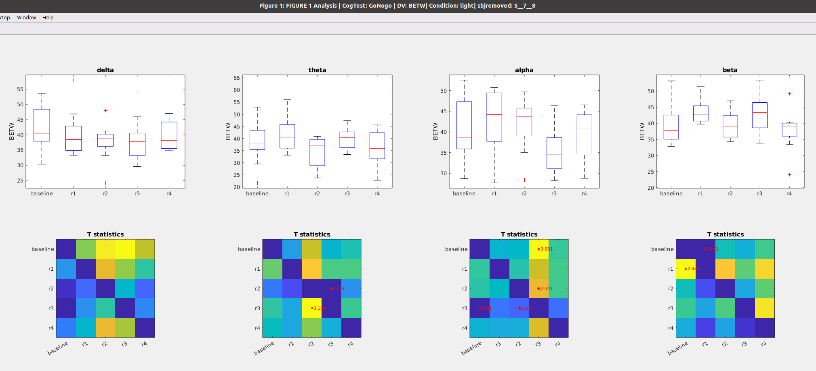

￼￼￼

## WPLI during GoNogo Task

### Figure 17a: Time course of **WPLI** after awakening **WITHOUT** blue light exposure

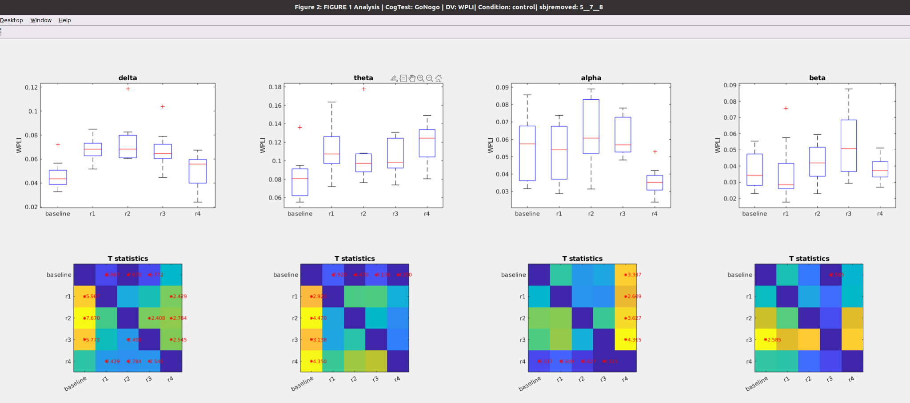

### Figure 17b: Time course of **WPLI** after awakening **WITH** blue light exposure

